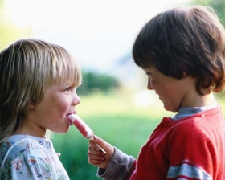
Laugh & Learn

The Mystery of Kindness
________________________________________

Thought for Today –
Kindness is more important than wisdom, and the recognition of this is the beginning of wisdom. - Theodore Isaac Rubin
________________________________________


November 13 is World Kindness Day. So for this edition of Laugh and Learn we’ll focus on kindness and enrich both our English and our lives.

Today I sat in a dentist’s chair in Svitavy, the Czech Republic, and experienced kindness. I was there due to my carelessness. Last week in school classes we played a game that included Halloween masks and wrapped toffee candy. At the end of the week I had some candy left from the classes so I ate one, a delicious soft caramel toffee. Instantly I knew it was a mistake. The candy pulled a cap from a tooth.


A Svitavy friend showed kindness by calling her dentist and making an appointment for me. Today this friend showed kindness by going with me to the dentist as my interpreter. The dentist showed kindness by accepting me as a patient on short notice. She cleaned the cap and it back into place. When I reached for my wallet, she waved it off and in kindness would accept no money for her service. I felt a little bad about this as I wished to pay. But the whole experience of the tooth and cap was covered by a sea of kindness.

Is such an experience rare? Nor for me. I often experience kindness from Czech friends and neighbors.
 School teachers treat me kindly, sending me nice emails, inviting me to dramas, and even bringing me coffee to the classroom.
 Many students have been not only respectful, but kind, helping me arrange supplies and interpreting with administrators.
 A lady at the train station not only sells tickets to Nancy and me, but she makes sure we get on the right train.
 Last week I went to an electric supply store looking for an electrical part. The store did not have what I needed, but an employee left the store and took me to another store to get this part. She stayed with me until I had purchased the necessary item. Was this business as usual? It was more than that. It was excellent customer service, and it was a special act of kindness.
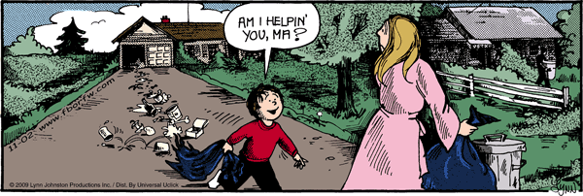
 I receive kindness in the labor office, the immigration police office, the museum and Fabrika, the grocery stores, in restaurants and from the neighbors in our flat.

Where does kindness come from? I am often asked, “How do you explain cruelty and evil in this world?” But no one has ever asked me, “How do you explain human kindness?” If I accepted the concept that life began bottom up [amoeba to fish to frog, etc] I should be more surprised at receiving kindness than meanness. In nature the big wolf eats the rabbit and the big fish eats the little fish. This is normal. Kindness is a surprise.
This month includes both World Kindness Day and Thanksgiving Day [fourth Thursday in November in the USA]. So let’s be grateful for kindness…that special divine ingredient that has been placed in each of our hearts.
I’ve been counting acts of kindness. I challenge you to do the same. In the past seven days, how many words and acts of kindness can you recall? Make a list and enjoy it.
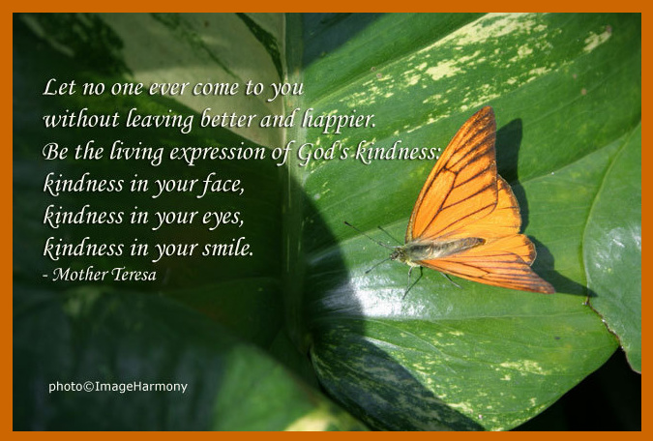

"Because your loving-kindness is better than life, my lips shall praise you." [Ps. 63:3]
VOCABULARY…from a thesaurus
Main Entry: | Kindness, a noun
Definition: | compassion, generosity
Synonyms: | affection, altruism, amiability, beneficence, benevolence, charity, consideration, cordiality, courtesy, decency, delicacy, fellow feeling, forbearance, gentleness, good intention, good will, goodness, grace, graciousness, heart, helpfulness, hospitality, humanity, indulgence, kindliness, magnanimity, mildness, patience, philanthropy, service, solicitude, sweetness, sympathy, tact, tenderness, thoughtfulness, tolerance, understanding, unselfishness
Antonyms: | cruelty, harshness, meanness
Main Entry: | Kindness, a noun
Definition: | helping act; service
Synonyms: | accommodation, aid, alms, assistance, benediction, benefaction, benevolence, blessing, boon, boost, bounty, charity, dispensation, favor, generosity, good deed, good turn, help, indulgence, lift, mercy, philanthropy, relief, succor
Antonyms: | barbarism, cruelty

The Links

Glen Campbell Try A Little Kindness Live

http://www.youtube.com/watch?v=JX7NNMKBPsw

Patti Labelle - Then My Living Will Not Be In Vain

http://www.youtube.com/watch?v=edBGuudFeu8&feature=PlayList&p=16F490979FF75E0D&playnext=1&playnext_from=PL&index=39

Sheriff Colin.

http://www.funnieststuff.net/viewmovie.php?id=1359

The Laughs

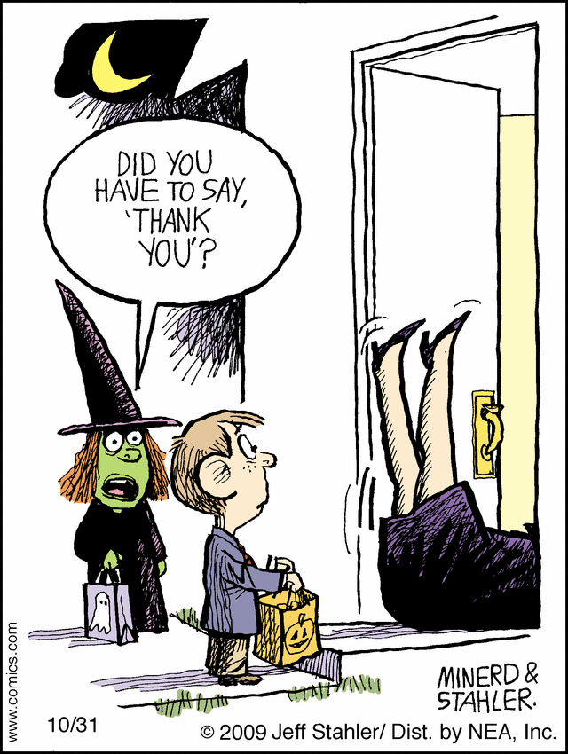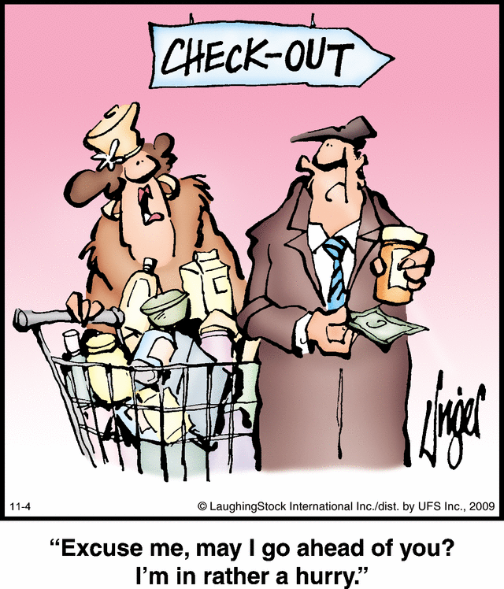

A LITTLE KINDNESS GOES A LONG WAY
A few people can't seem to differentiate between kindness and rudeness. This may help:
---Kindness takes time and effort; rudeness takes just a finger.
---Kindness reminds people to "care" and "love"; rudeness reminds people of other four-letter words.
---Kindness asks the question "Can I assist you in any way?"; rudeness asks the question "Can I assault you in any way?"
---Kindness expects you to show your heart to others; rudeness expects you to show your tongue.
---Kindness can make you a Good Samaritan; rudeness can make you a good radio DJ.
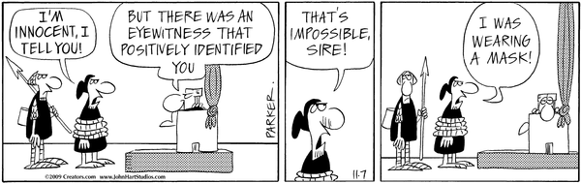
GOD'S EMAIL
One day God was looking down at Earth and saw all of the evil that was going on. He decided to send an angel down to Earth to check it out. So He called one of His best angels and sent the angel to Earth for a while. When she returned she told God, yes it is bad on Earth, 95% is bad and 5% is good and kind.

Well, He thought for a moment and thought maybe He'd better send down a second angel to get another point of view. So God called another angel and sent him to Earth for a time too. When the angel returned he went to God and told him "Yes, the Earth is in decline. 95% is bad and 5% is good and kind." God said this was not good enough.

So He decided to send e-mail to the 5% that were good. He wanted to encourage them, give them a little something to help them keep going.
Do you know what that e-mail said?
---
---
---
Oh, you didn't get one either, huh? Bummer.

[Bummer means bad news or disappointment or loss. It means something that depresses or frustrates. "Getting stranded at the airport was a real bummer." It can mean to depress, sadden, dispirit, as in "He's been really bummed out since his girlfriend moved to California."]

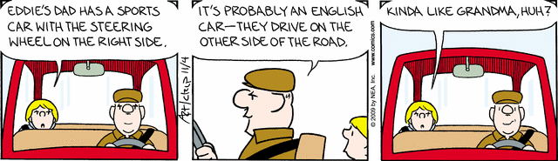


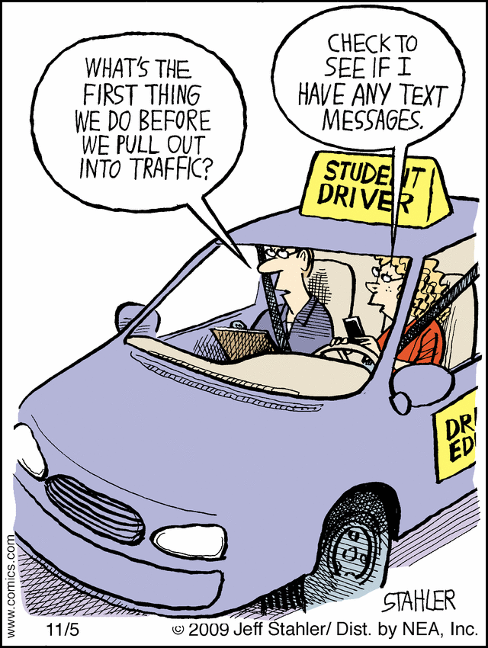

To subscribe [or unsubscribe] to LUPTON’S LAUGH AND LEARN, send your request in the subject line to Daninsvitavy@gmail.com You may forward Laugh and Lift to a friend.

Into Overtime…with two true stories…for those that love to read and read

George C. Boldt story

One stormy night many years ago, an elderly man and his wife entered the lobby of a small hotel in Philadelphia. Trying to get out of the rain, the couple approached the front desk hoping to get some shelter for the night.
"Could you possibly give us a room here?" the husband asked.
The clerk, a friendly man with a winning smile, looked at the couple and explained that there were three conventions in town. "All of our rooms are taken," the clerk said. "But I can't send a nice couple like you out into the rain at one o'clock in the morning. Would you perhaps be willing to sleep in my room? It's not exactly a suite, but it will be good enough to make you folks comfortable for the night."
When the couple declined, the young man pressed on. "Don't worry about me, I'll make out just fine," the clerk told them.
So the couple agreed. As he paid his bill the next morning, the elderly man said to the clerk, "You are the kind of manager who should be the boss of the best hotel in the United States. Maybe someday I'll build one for you."
The clerk looked at them and smiled. The three of them had a good laugh. As they drove away, the elderly couple agreed that the helpful clerk was indeed exceptional, as finding people who are both friendly and helpful isn't easy.
Two years passed. The clerk had almost forgotten the incident when he received a letter from the old man. It recalled that stormy night and enclosed a round-trip ticket to New York, asking the young man to pay them a visit.
The old man met him in New York, and led him to the corner of Fifth Avenue and 34th Street. He then pointed to a great new building there, a pale reddish stone, with turrets and watchtowers thrusting up to the sky.
"That," said the older man, "is the hotel I have just built for you to manage."
"You must be joking," the young man said.
"I can assure you I am not," said the older man, a sly smile playing around his mouth.
The older man's name was William Waldorf-Aster, and that magnificent structure was the original Waldorf-Astoria Hotel. The young clerk who became its first manager was George C. Boldt. This young clerk never foresaw the turn of events that would lead him to become the manager of one of the world's most glamorous hotels.
Airport Story
I was catching a later flight to St. Louis, then on to Minnesota. A couple of seats in front and the aisle over sat a very pretty lady. She smiled back at me, I smiled at her noticing her pretty floral dress.
The rest of the flight was uneventful, but as I was getting off the plane I noticed her again standing by the prompters seeing what flight she was to take and what gate. I stood beside her looking for my gate, and flight number. I commented to her that I had noticed her on the flight to St. Louis and she had on a pretty dress. She said "Thank you", I asked what flight she was taking? She said to "Phoenix". I looked and she had a two-hour layover, I also had a two and a half hours layover and asked her if she would like to go to the cafeteria for something to eat or drink. She said "Sure". We introduced ourselves on the way down the ramp, and she told me that her name was "Phyllis". I laughed and said "my name is Phyllis also".
As we sat in the booth she began telling me that she had been told she was dying of cancer and had less than 6 months to live. She was on her way to visit her children and grandchildren before she began taking treatment. She then told me that she had never flown before and she had prayed a specific prayer. She was afraid she would get lost at the airport and not be able to fine her way to the gate, and didn't know what she was going to do for the two hours she was there. She prayed, that someone would meet her at the gate and stay with her until she left the airport. She then asked me "Are you an Angel God has sent"? No, I assured her I was no angel, but did God use me to answer her prayer? Yes.

