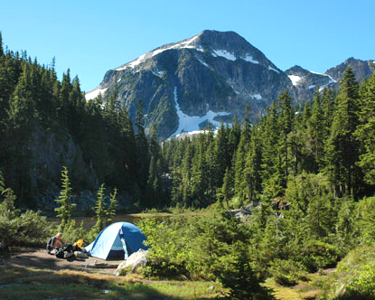
laugh and Learn

Summer Camping
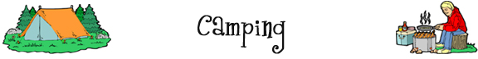

What I like about camping is you can get really dirty. Either you're all by yourself, so no one else sees you, or everyone you're with is just as dirty as you are, so nobody cares. Boy Scout

Fill in the blanks below with words from this box:
tent  set  campfire  marshmallows  itch  fresh  sing | roast  hiking  fishing  lake  axe  pollution  tell |  | river  sleeping bags  mosquitoes  bug spray  chop  campsite  cooler
Camping
When the weather starts to get warm, many families like to experience the __________ air of the country away from the ______________ of the city. They pack up their ____________ and a _____________ full of food and head out to the woods near a body of water such as a ___________ or a _______________. After arriving at the _____________, the first thing to do is ___________ up the _______________.

The Campfire
At night, people sit around the ____________ and _________ scary stories or ____________ songs. Somebody has to ___________ wood for the fire. To do this, they’ll need an ______________. If anybody gets hungry, they can ___________ hotdogs or ______________ over the fire.

Camping activities
One thing people like to do in the woods is put on their boots and go ______________. Another thing they like to do is grab a rod, some hooks, and some worms and go ________________.
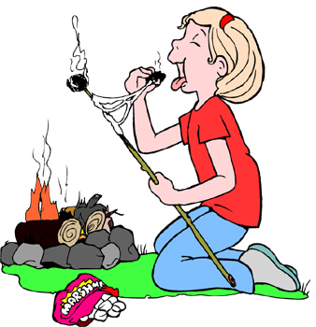 |  | Bugs  One of the worst things about camping is the ________________. If they bite you, you will _____________ badly. That’s why it’s important to put ______________ on when you are in the woods.

Pronunciation of regular past tense words. If the word ends in…
[1] t or d, the past tense suffix -ed is pronounced [Id]. Two syllable word
[2] b, v, w, m, n, l, r, z, y, g, the past tense suffix -ed is pronounced [d]. One syllable word
[3] p, f, s, sh, k, x the past tense suffix -ed is pronounced [t]. One syllable word

Roasted is two syllables, pronounced roast-id
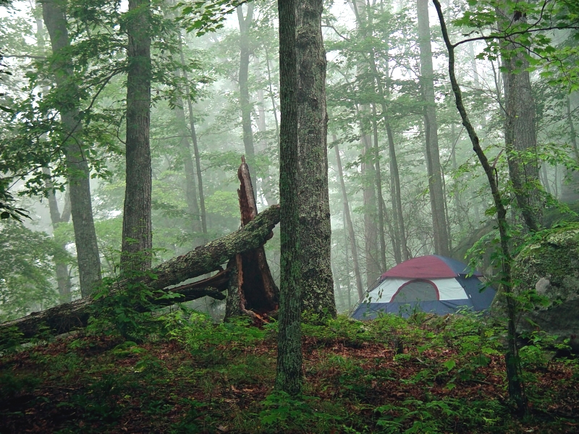
Polluted is two syllables, pronounced pollut-id
Headed is two syllables, pronounced head-ed
Sprayed is one syllable, pronounced sprayd
Arrived is one syllable, pronounced arrivd
Grabbed is one syllable, pronounced grabd
Opened is one syllable, pronounced opend
Fished is one syllable, pronounced fisht
Itched is one syllable, pronounced Itcht
Packed is one syllable, pronounced pakt
Hiked is one syllable, pronounced hikt
Camped is one syllable, pronounced campt
Chopped is one syllable, pronounced chopt

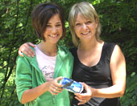
While camping in the Quaker Run area of Allegany State Park, NY, there are always numerous bear sightings. During a hike, I came across a lot of trash behind our cabin. Discouraged at how anyone could spoil this beautiful land, I went back to the cabin to get a garbage bag. As my daughter and I were cleaning up, we came across a lot of pop cans. None were opened from the top, but they all had a large gash right down the side through the aluminum. It was then we realized we were picking up bear trash! It made the task much more interesting. [by Lynn Batt, Lockport, NY]

English camp
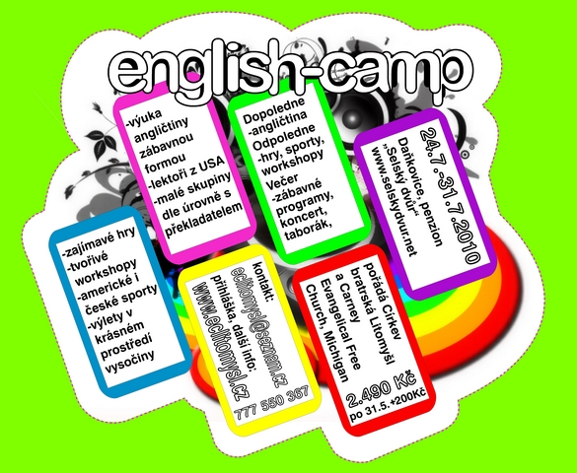
Laugh and Learn readers are invited to English Camp, 24-31 July. Mr. Dan thinks that L&L readers are the ideal campers.
English Camp is for university and high school students 15 years old or above…or… families also come to camp and these may bring children younger than 15. First year campers come for the experience of learning and practicing English with native Americans, and also for the full camp experience of sports, crafts, enjoying nature, music and campfires, and many laughs. Many will come to English Camp for the second, third or fourth year, and these come to also see their camp friends, both Czech and American friends.
Each camper is in a group of 6-10 at the same level of English comprehension. The mornings involve practice in English with activities and programs in the afternoon and evenings. American teachers and Czech translators are provided in everything. Many claim that this camp is the best week of their summer…or life.

The cost for this full week of camp is very low. To see pictures of the last three English Camps and to learn more about signing up for camp, click on the first link.

The links:
English Camp Fotogalerie and Information

http://www.eclitomysl.cz/

How to Choose a Backpacking Tent
Royal Secret – English Camp 2010

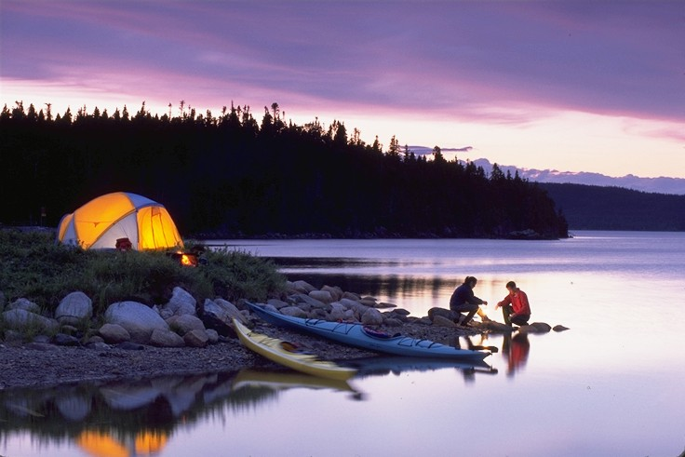
http://www.youtube.com/watch?v=UT_Ic4XZ6_k

Funny…Jim Gaffigan – Camping and bacon

http://www.youtube.com/watch?v=qle-vjHoQa4

Camping Tips: Respecting Nature

http://www.youtube.com/watch?v=x0XqDUIGTRw

Arctic Painting and Camping #30. To see more of these videos, change the #30 to a higher or lower number and hit enter

http://www.viddler.com/explore/CoryTrepanier/videos/30/

The laugh:

Elementary, My Dear Watson
Sherlock Holmes and Dr. Watson go on a camping trip, set up their tent, and fall asleep. Some hours later, Holmes wakes his faithful friend.
"Watson, look up at the sky and tell me what you see." Watson replies, "I see millions of stars."
"What does that tell you?"
Watson ponders for a minute. "Astronomically speaking, it tells me that there are millions of galaxies and potentially billions of planets. Astrologically, it tells me that Saturn is in Leo. Timewise, it appears to be approximately a quarter past three. Theologically, it's evident the Lord is all-powerful and we are small and insignificant. Meteorologically, it seems we will have a beautiful day tomorrow. What does it tell you?"
Holmes is silent for a moment, then speaks. "Watson, you idiot, someone has stolen our tent."
A camp leader saw a camper sitting alone. 'Why don't you play with your friends?' he asked.
'Because I only have one friend,' the girl replied. 'And I hate her.'
Camper: There's a leak over my bunk!
Camp leader: Don't complain. It only leaks when it rains.
Camp leader: A camper just swallowed a pen. What should I do?
Camp Doctor: Use a pencil.
Camp leader: Jake, why did you put that snake in Annie's bed?
Jake: Because I couldn't find a frog!
At the end of camp, Julie won the prize for neatest trunk. Her mother was amazed. 'How did your suitcase get so neat?' she asked her messy daughter.
'It was easy,' said Julie. 'I just never unpacked!'

A New York boy was being led through the swamps of Louisiana by his cousin.
"Is it true that an alligator won't attack you if you carry a flashlight?"
The cousin replied, "It depends on how fast you carry the flashlight."
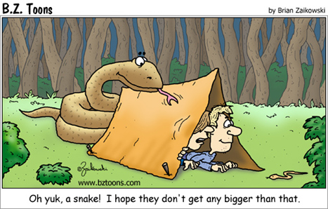

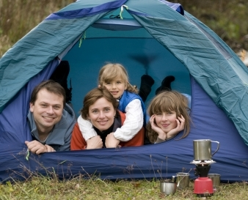
Camping Teamwork
The loaded minivan pulled into the only remaining campsite. Four children leaped from the vehicle and began feverishly unloading gear and setting up the tent.
The boys rushed to gather firewood, while the girls and their mother set up the camp stove and cooking utensils.
A nearby camper marveled to the youngsters' father, "Sir, that is some display of teamwork." The father replied, "I have a system; no one goes to the WC until the camp is set up."
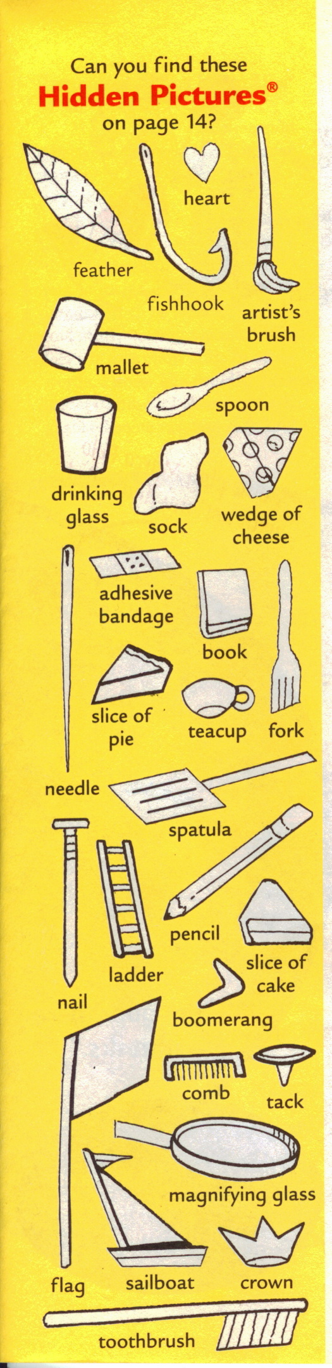

find the hidden pictures


