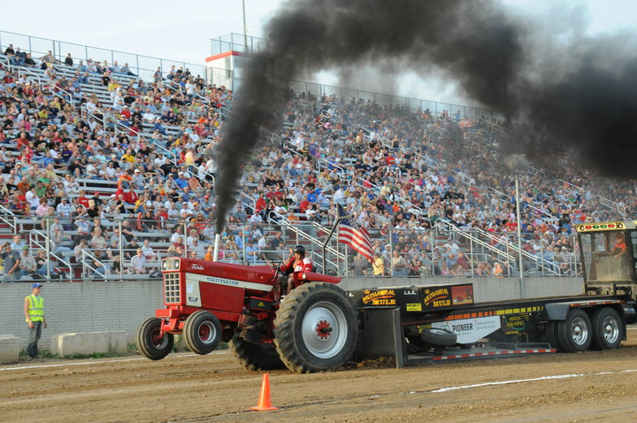
Laugh and Learn

SummeR

Festival

FUN!
Tractor Pull at County Fair
Summer weekends can provide many hours of family fun for adults, teens and children. There are vacations, beautiful nature, water parks, and festivals. Most cities and towns have local festivals, so a family can visit several of these over the summer months. Here are some of the primary types of fests…some of these may surprise you.
The Block Party
Do you know what a block is? A block can be what builders use to build walls for houses; blocks are wooden or plastic toys for children to stack high; and a block is also a neighborhood in a city or town. This kind of block is a rectangular or square area in a city surrounded by streets and usually containing several houses or apartment buildings. "He lives in the next block."
A Block Party is a social picnic for the people who live near your home. I visited my sister Judy in Dallas, Texas this spring on the weekend when her neighbors held their annual block party.
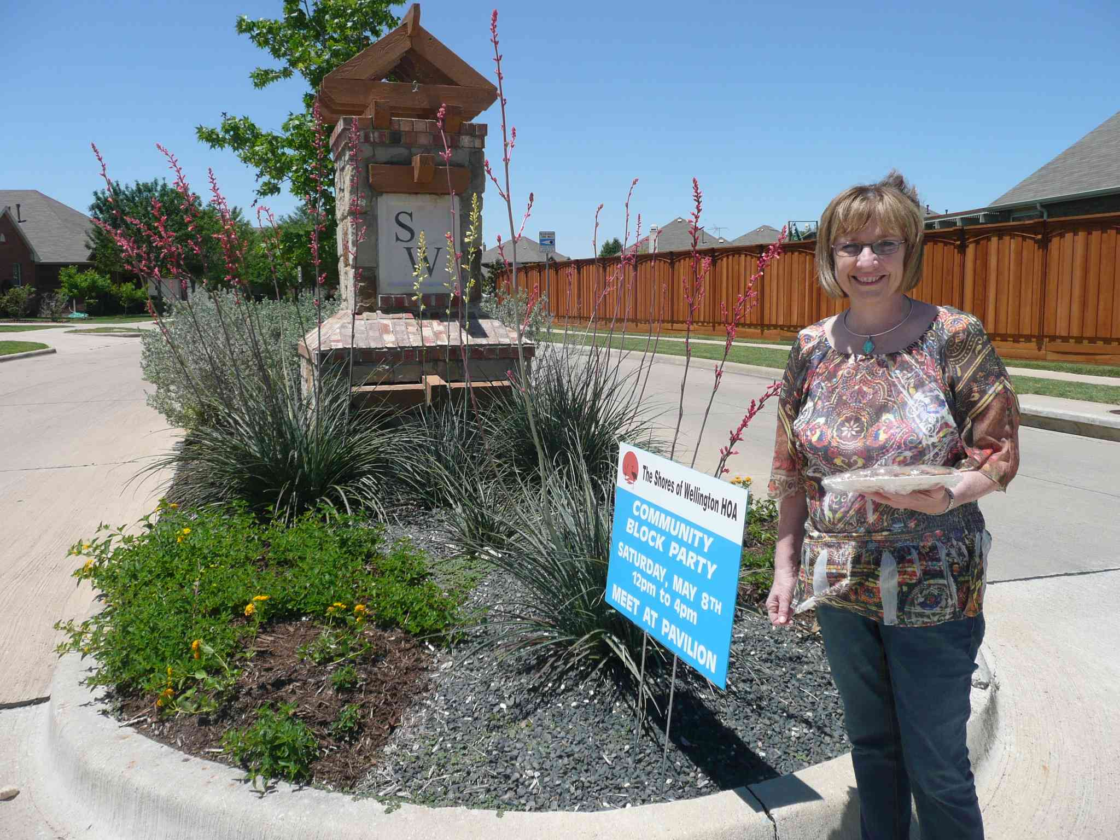
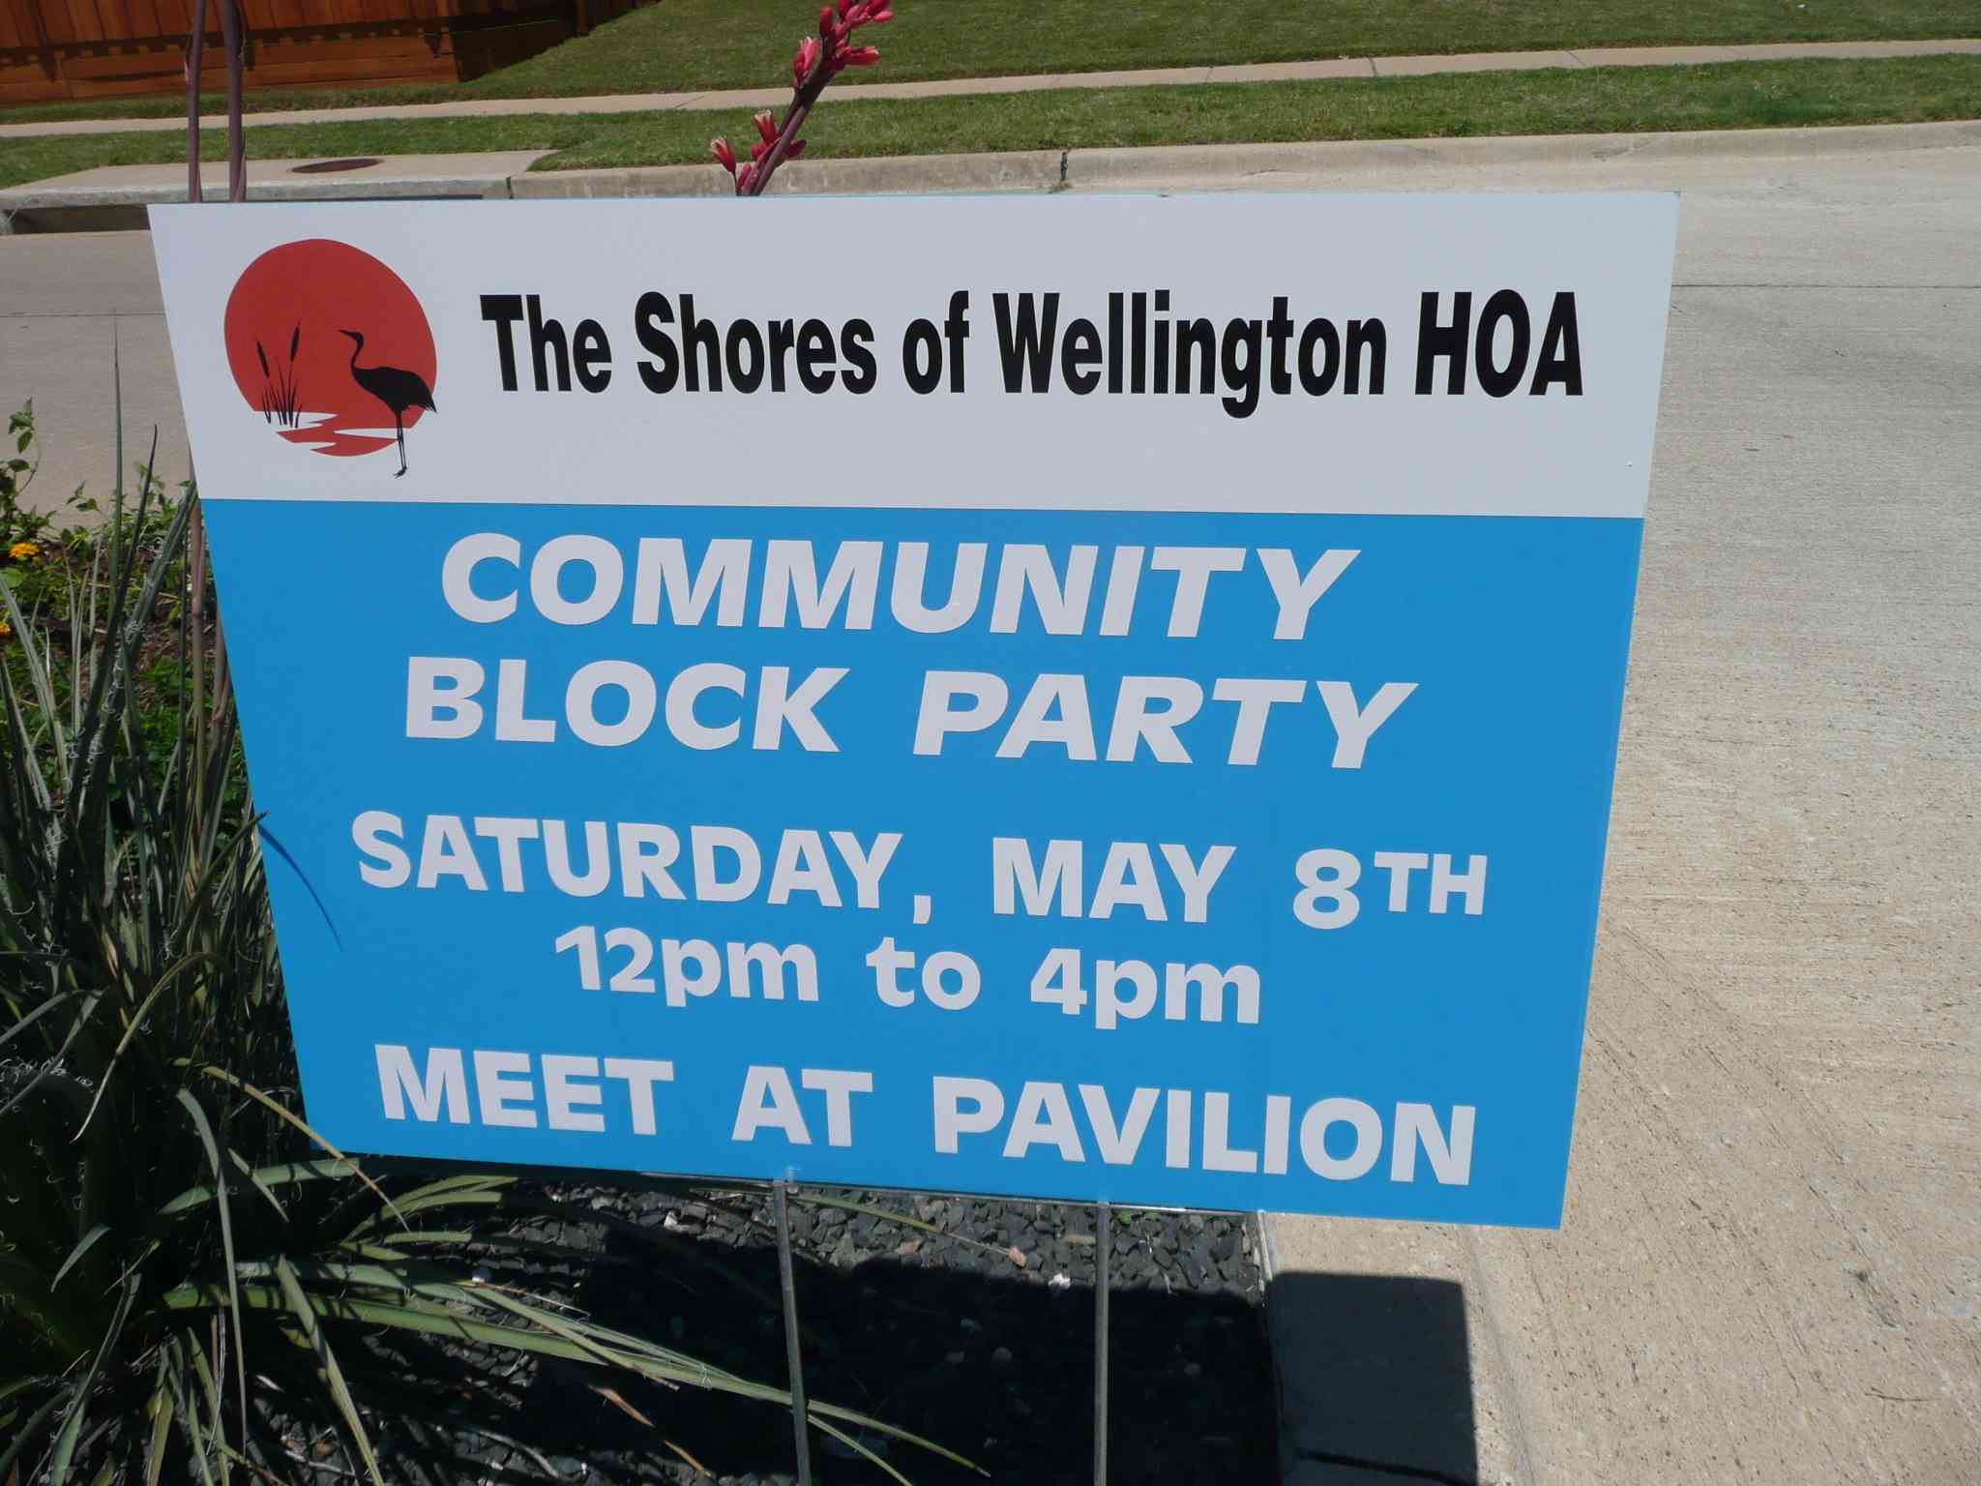
Sign inviting to neighborhood block party Mr. Dan’s sister with cookies for the block party
This block party is for three or four blocks. Neighbors come to eat and talk. They may see neighbors they know well and consider friends. They may meet some neighbors for the first time. Judy met a neighbor she didn’t know and was invited to her home for a women’s club. Judy accepted the invitation. This block party included good food, a clown, face painting, a caricature artist, a blowup jumper for children, swimming, and loud music from CDs, not live this day. A block party is small and simple.
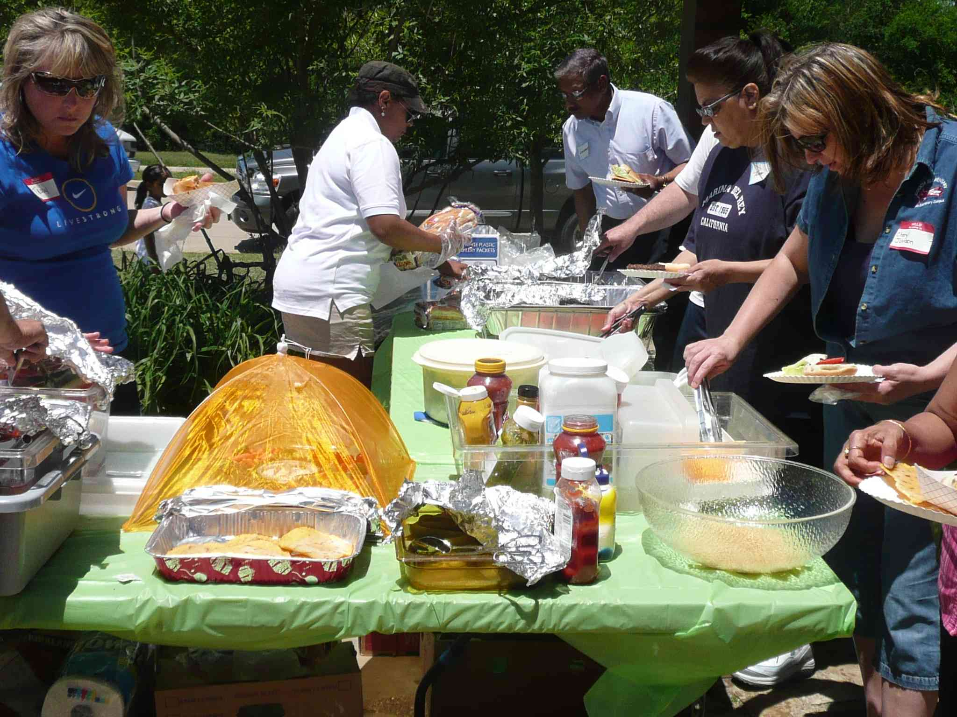
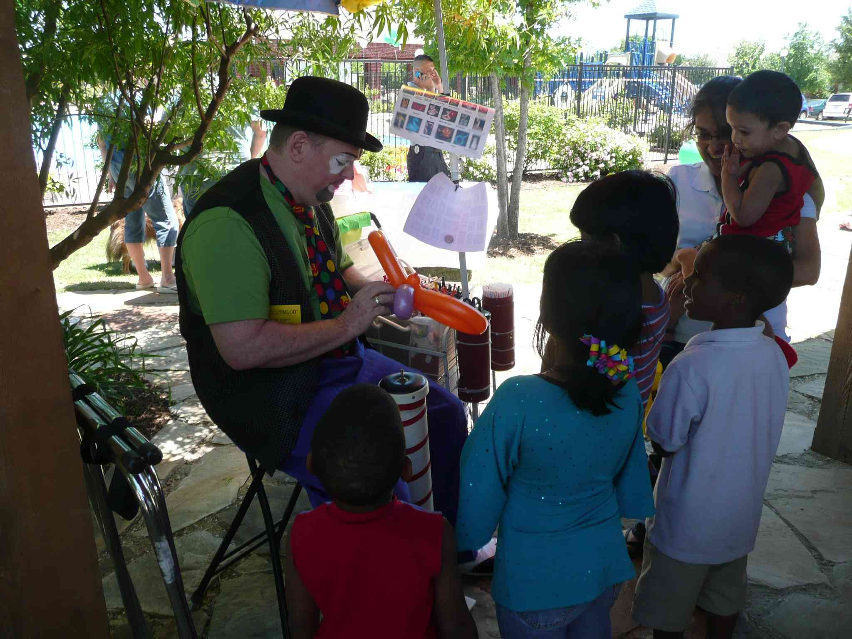
Clown twisting long balloons into animals Hamburgers & potato chips, fruit & vegetable salads
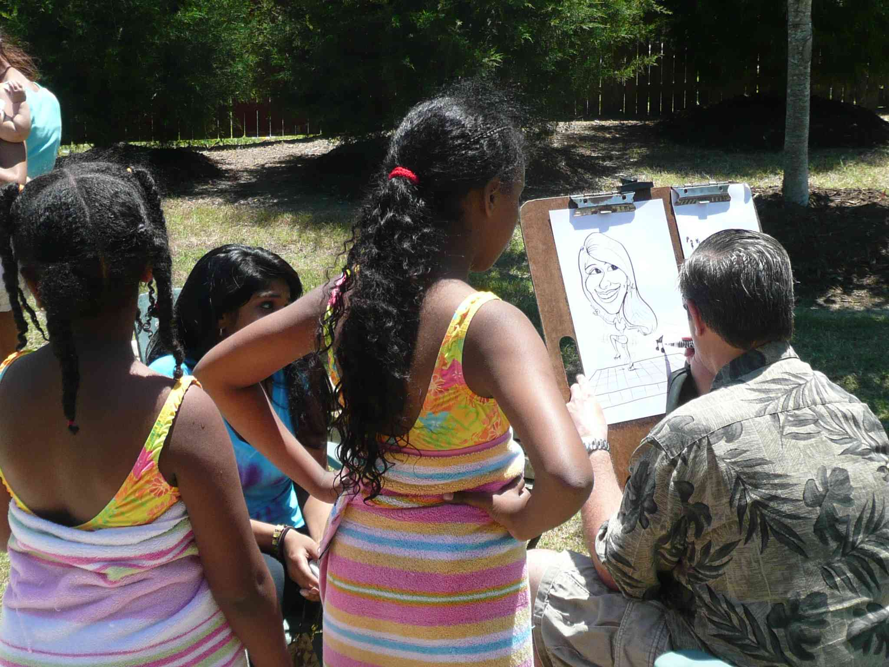
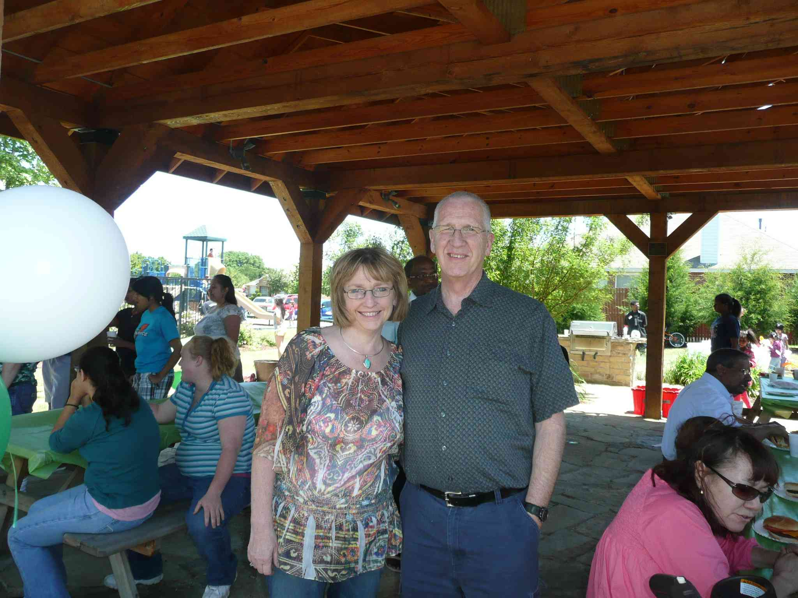
Neighbors eating & talking; Mr. Dan with sister Posing for Artist. Note the ethnic diversity
Block parties are easy to plan, not expensive, and a great time for enjoying those who live on your block. Everyone hopes and prays for a sunny day.
City Festival
In both the Czech Republic and the USA, most towns and cities have a weekend festival. A city festival is for thousands of people, and will include music shows, more deep fried food than is healthy for anyone, and a midway. A midway is the area where the games of chance and the fun and scary rides will be found.
The last weekend in May is called Memorial Day weekend in the USA. Nancy and I went to the Brat Festival in Madison, WI. This festival is a charity fundraiser. All the profit is used to help charities like the Boy Scouts and Girl Scouts.
A Brat is a bratwurst, or a sausage. In the USA a Brat is eaten in a bun like a hotdog. A total 209,376 brats were sold at this year's event on Willow Island at the Alliant Energy Center grounds. The Brat Fest claims that is a new work record. Here you see the volunteer cooks barbecuing Brats.

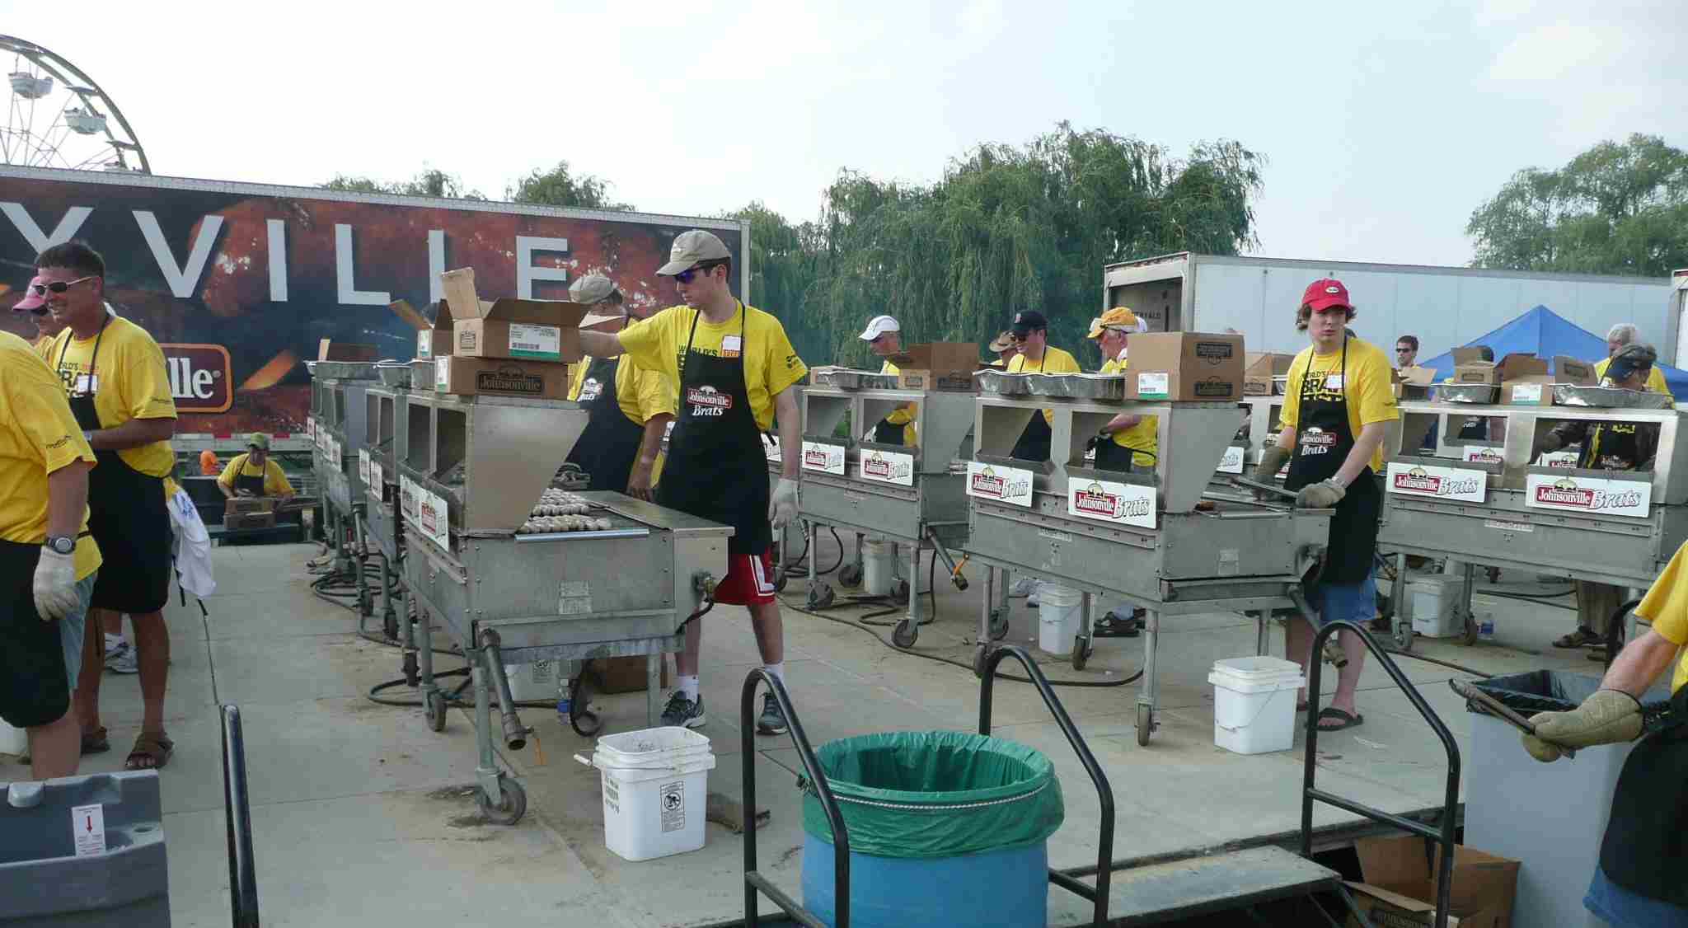
Here is the famous Oscar Mayer Bratmobile auto. Oscar Mayer is a business that produces sausages.
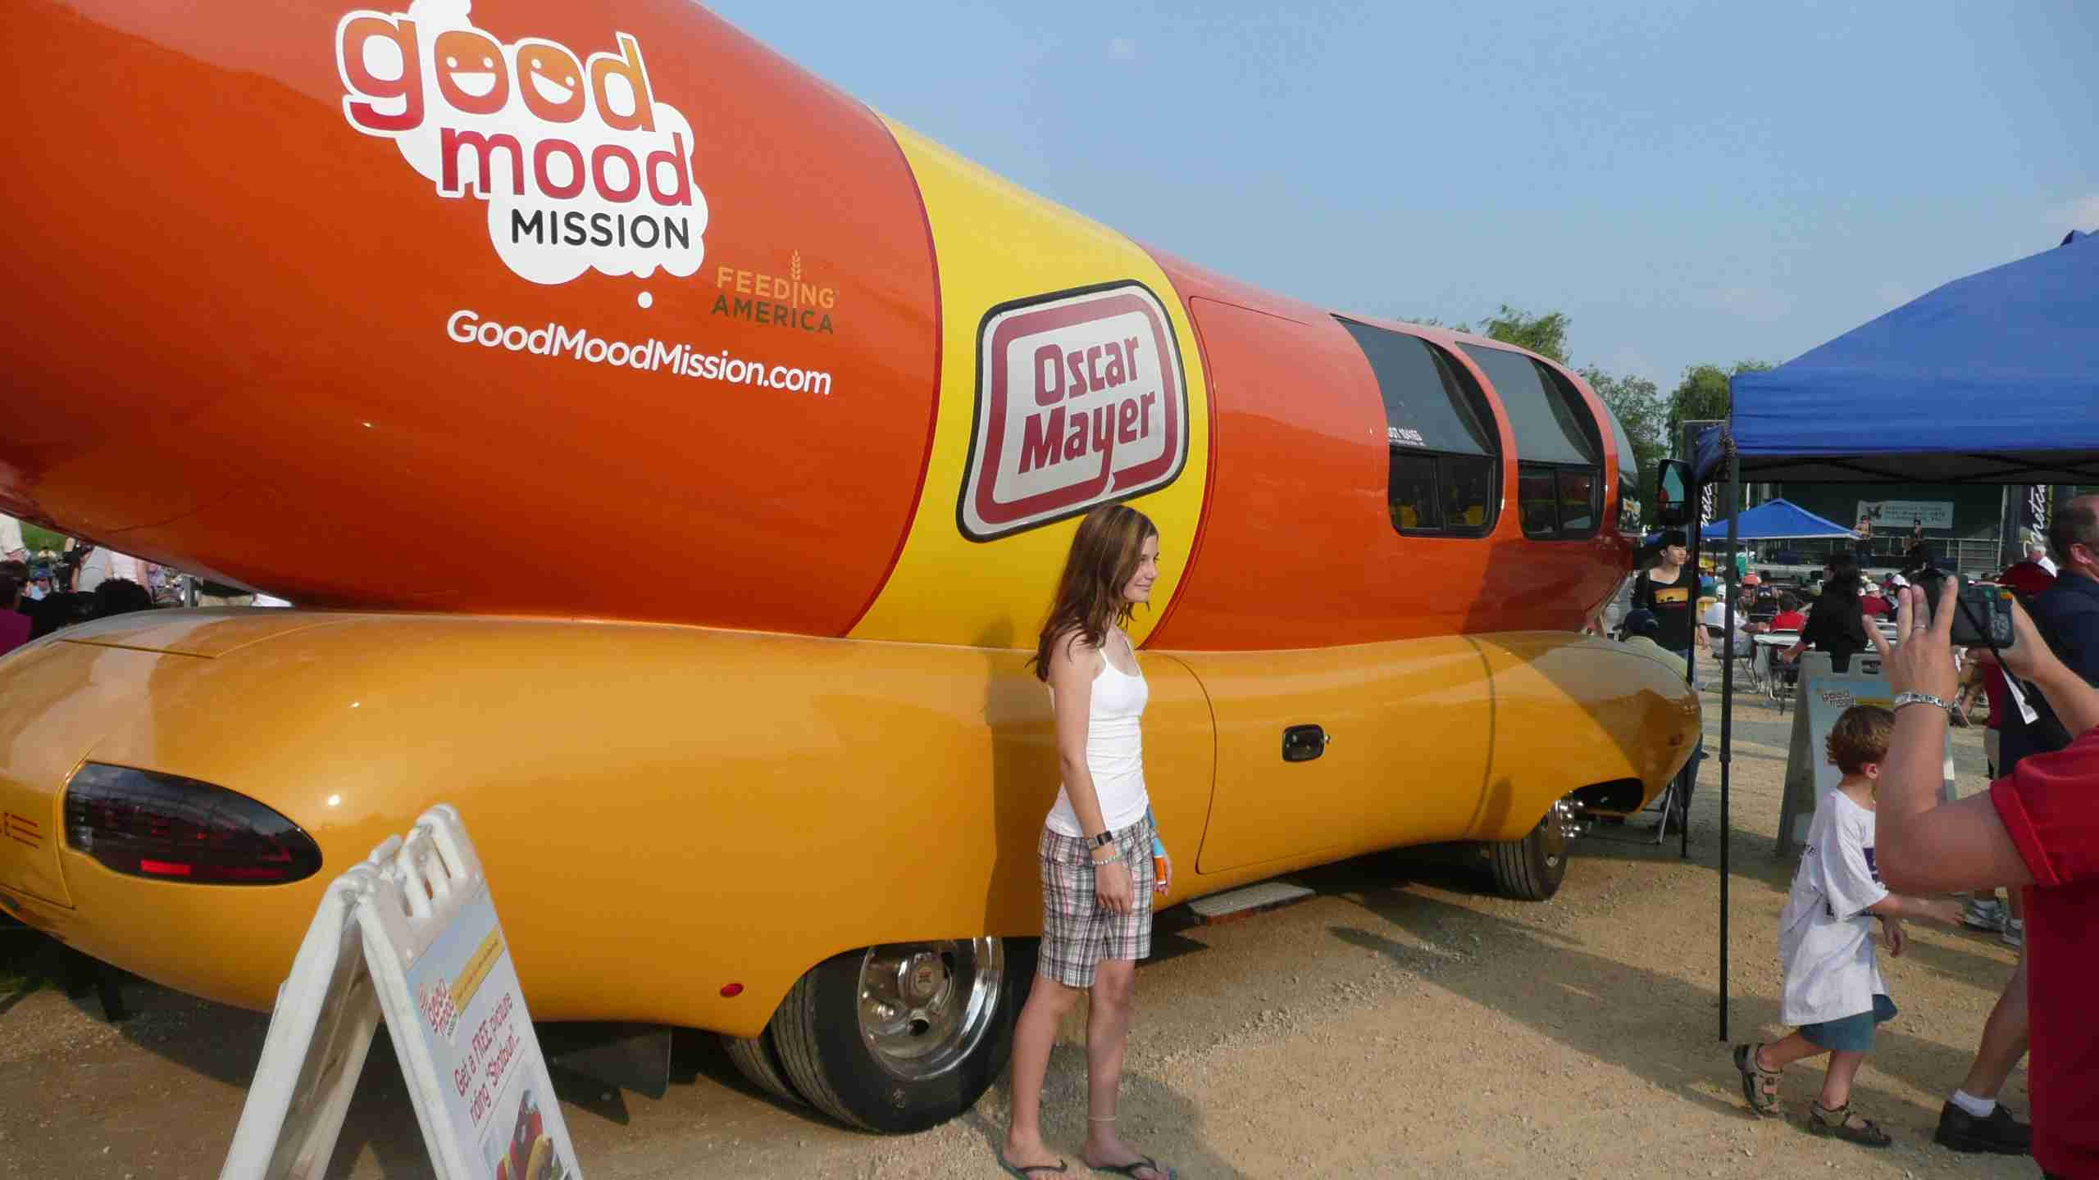
The links:

Racine County Fair
http://www.racinecountyfair.com/

Brat Fest
http://www.bratfest.com/

The laugh:

The Brat Fest featured four stages where bands played. Scores of singers and bands gave concerts of rock, country western, jazz, soul, gospel, and folk music. Here are people eating and drinking while enjoying music at one of the four concert stages.
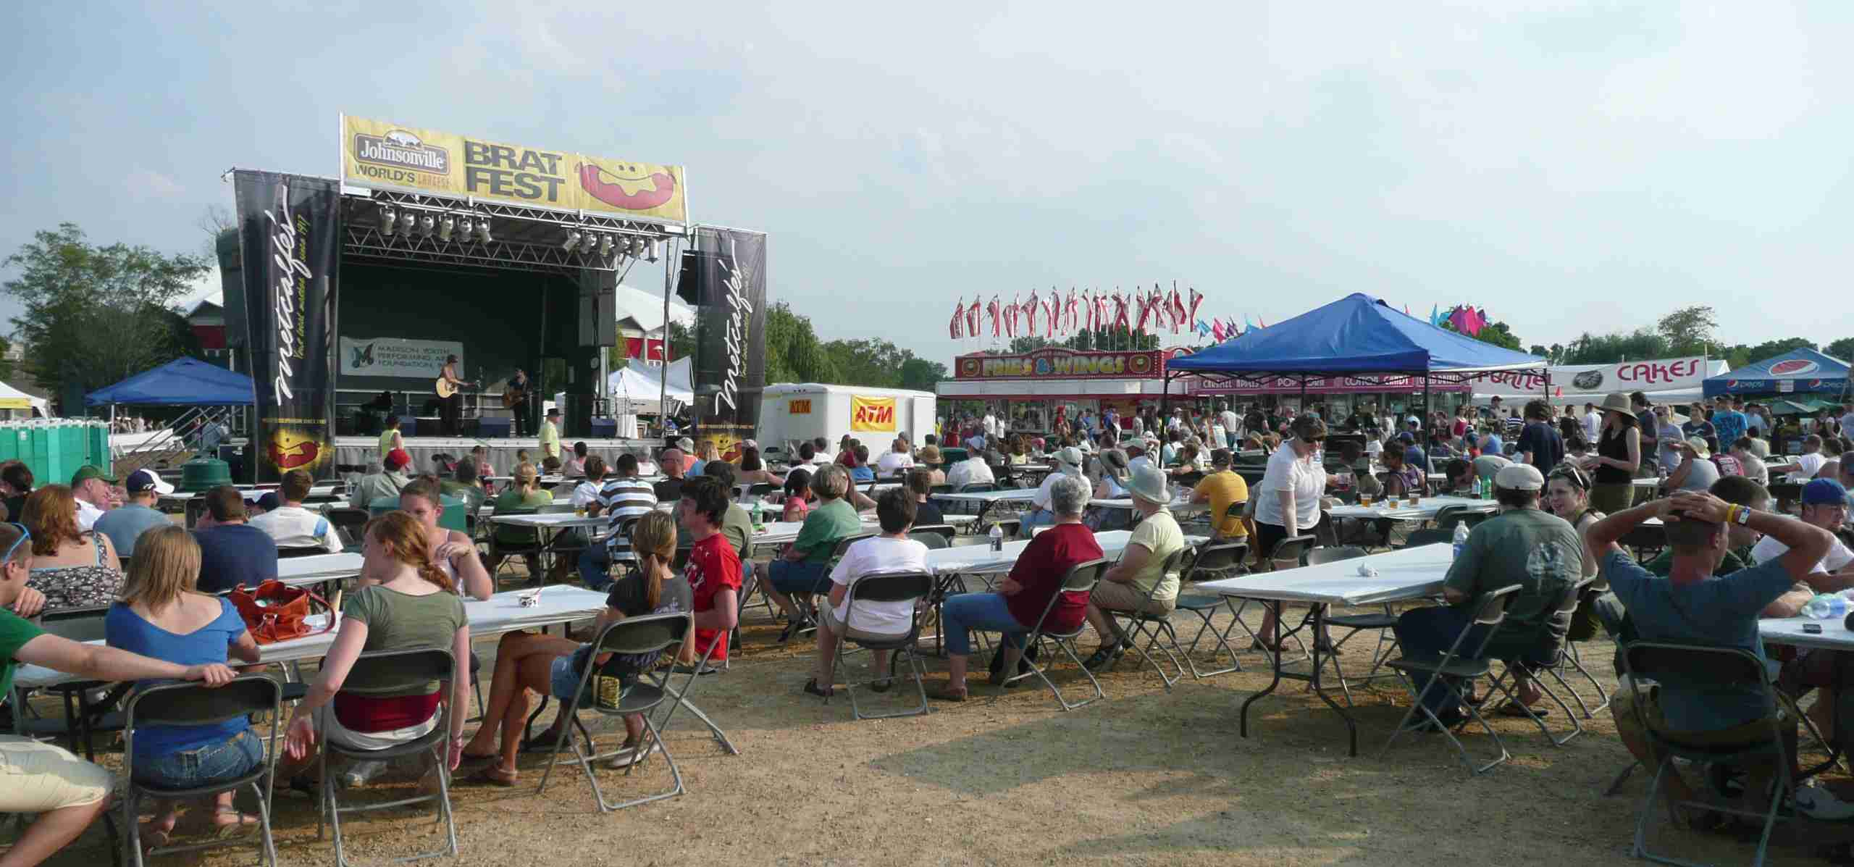

The Brat fest had a Midway with lots of fun things to do.
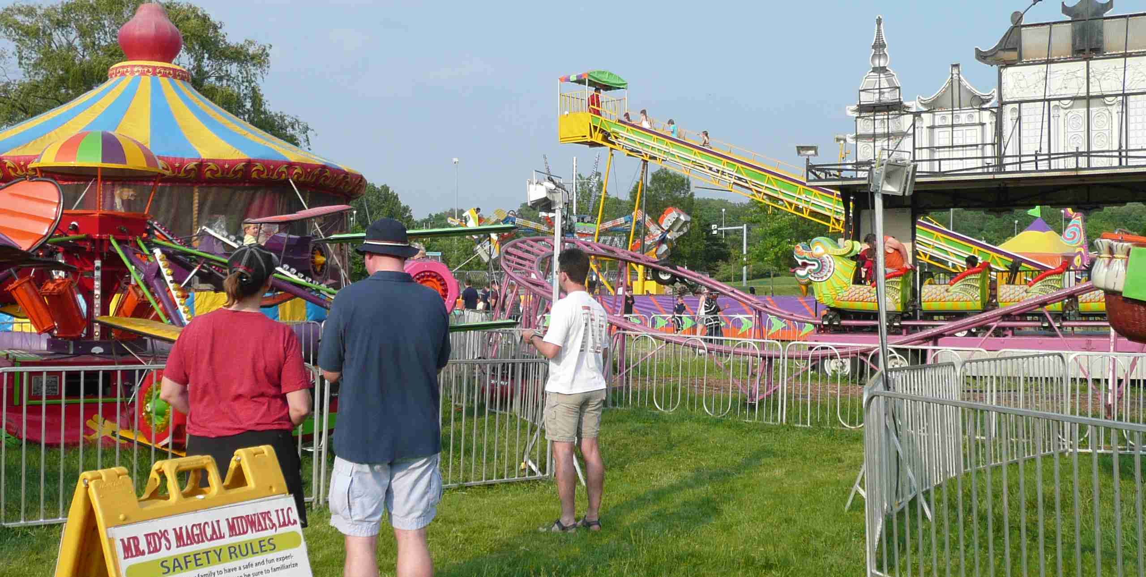

County Fair
Every American lives in a county, which is a district region of about 40 kilometers square. A county fair is an event held in the summer or early fall. Fairs give communities a chance to show off their unique habits and talents and can be a wonderful expression of a county’s personality. In farming towns or counties with a major agricultural base, the fair offers contests for the biggest produce, the best flowers or healthiest livestock. Agricultural groups like 4-H encourage teenagers to enter their livestock, teaching a new generation about the values of farming and quality agricultural work. Other events, like sheepdog trials or horse races, pit local owners and breeders against one another, bringing fame and sometimes fortune to the winner, as well as entertainment to the crowd.
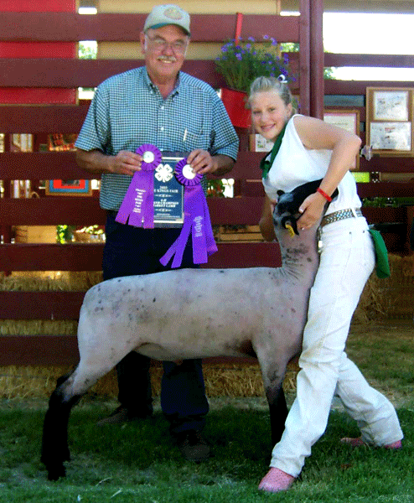
In addition to agricultural displays, county fairs often include arts and crafts exhibitions. These displays may cover a wide variety of artistic mediums, from painting and photography to sculpture, quilt making and ornamental woodwork. County fairs may have tractor shows and rodeos. Of course, a county fair has a midway with games, food and fun rides like the tilt-a-whirl and Ferris wheel.
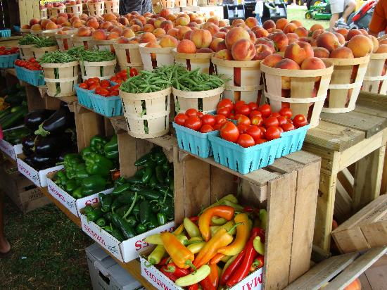
The county’s best fruits and vegetable on display
A Blue ribbon means First Place.

Eva and Jana from Svitavy at Racine County Fair Caramel Apple on the Midway
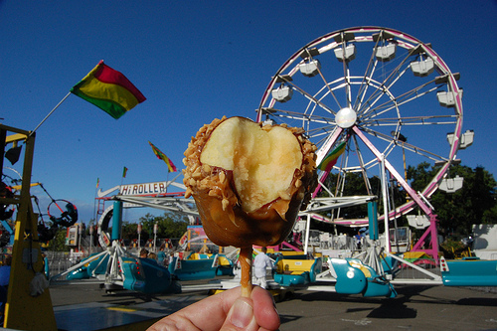
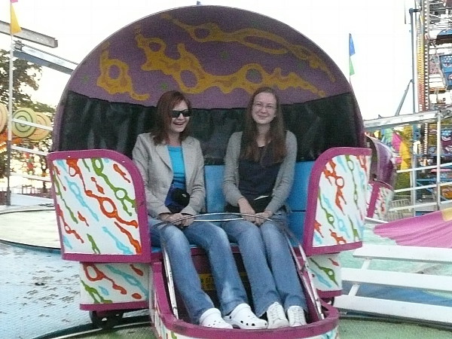
I hope you will enjoy your summer wherever you are, and I imagine it will include one or two festivals. Other traditional summer events include church picnics, summer camps, family reunions, and vacations. Nancy and I are in the USA, but we will return to Svitavy in June and look forward to summer fests and English Camp.
If you have an interest in English Camp, please look at this short video: http://www.youtube.com/watch?v=yt5dlUoDVuk
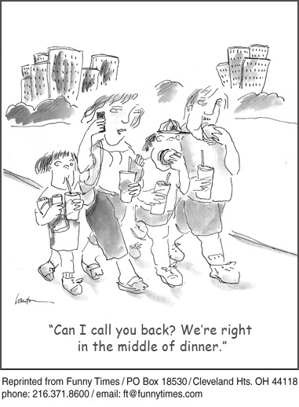
The Links
Brat Fest
http://www.youtube.com/watch?v=4T_oYPr87ic
County Fair Horse judging
http://www.youtube.com/watch?v=OY7-8eZ_pzk
Jackson County Fair where Mr. Dan grew up
http://www.youtube.com/watch?v=r-CNyCYoIUQ
Funny County Fair Ad
http://www.youtube.com/watch?v=zanuct12Rd4
County Fair Turkey Race
http://www.youtube.com/watch?v=qOYkXdqQVec

Josh and Barack Obama Visit the Blue Hill Fair
http://www.youtube.com/watch?v=L-DPf4YkOns

The Laughs
A perfect summer day is when the sun is shining, the breeze is blowing, the birds are singing, and the lawn mower is broken.
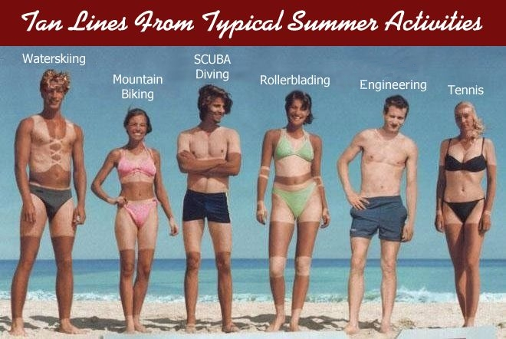

"Summer is the season when a man thinks he can cook better on an outdoor grill than his wife can on an indoor stove."
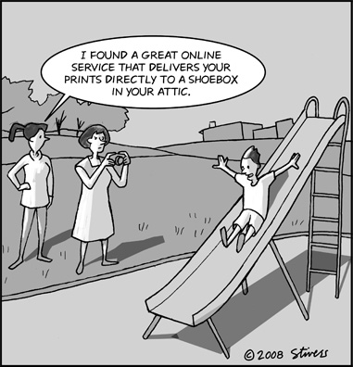
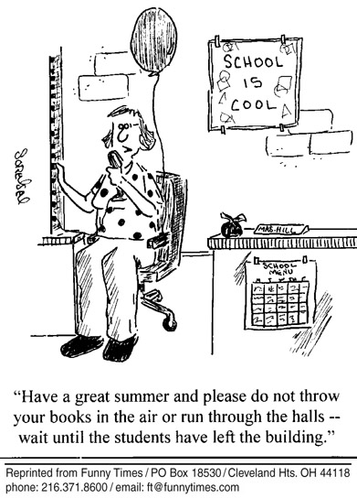

Mandy started working as an elementary school counselor and was eager to help students. One day, she noticed a girl standing alone on one side of a playing field, while the rest of the kids enjoyed a game of football at the other.
Sandy approached the girl and whether she was all right. The girl said she was.
A little while later, Sandy noticed the girl was in the same spot, still alone. Approaching again, she offered, "Would you like me to be your friend?"
The girl hesitated and then said, "Okay," looking at the Sandy suspiciously.
Sandy then asked, "Why are you standing here all alone?"
"Because," the little girl said, “I'm the goalie!”

“Teacher: Why were you late?
Joe: Sorry, teacher, I overslept.
Teacher: You mean you need to sleep at home too!”

I went on vacation last week. What a week it was. It only rained twice - once for three days, once for four.

