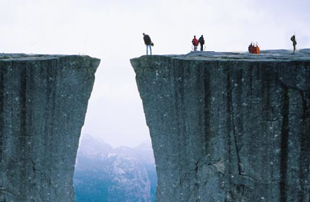
Laugh and Learn

The GAP

Your challenge is to bridge the gap which exists between where you are now and the goal you intend to reach.

The Learn
Definition of GAP

1. a break in a barrier (as a wall, hedge, or line of military defense)
2. a mountain pass – a ravine
3. a separation in space
4. an incomplete or deficient area, e.g., a gap in her knowledge
5. a break in continuity – hiatus, pause, interruption
6. lack of balance – disparity, e.g., the gap between imports and exports
7. a wide difference in character or attitude or values, e.g. the generation gap
8. a problem caused by some disparity, a communication gap, credibility gap
9. a major chain of clothing stores, with 1,335 GAP stores in North America


Examples of GAP
The child had a gap between her two front teeth.
The gap between the lead runner and the rest of the field continued to widen.
The sheep got through a gap in the fence.
There are unexplained gaps in his story.
The class filled in the gaps in my knowledge of biology.
She had taken several years off to raise a family, so there was a large gap in her work history.

Generation GAP
MILWAUKEE (AP) - For students entering university this fall, e-mail is too slow, phones have never had cords and the computers they played with as kids are now in museums.
Those who graduated from high school in June thinks of Clint Eastwood more as a sensitive director than as Dirty Harry urging punks to "go ahead, make my day." Few incoming freshmen know how to write in cursive or have ever worn a wristwatch. The America they have inherited is one of soaring American trade and budget deficits; Russia has presumably never aimed nukes at the United States and China has always posed an economic threat.
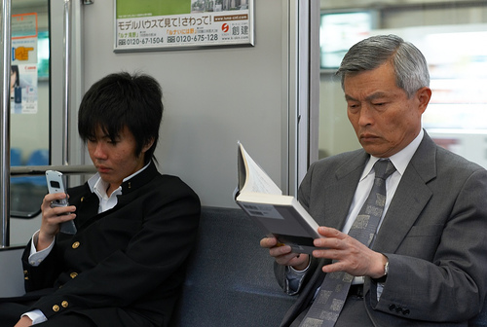
Nonetheless, they plan to enjoy college. The males among them are likely to be a minority. They will be armed with iPhones and BlackBerries, on which making a phone call will be only one of many, many functions they will perform. They will be flooded with computerized technology that will not distinguish information and knowledge, so it will be up to their professors to help them. A generation accustomed to instant access will need to acquire the patience of scholarship. They will discover how to research information in books and journals and not just on-line.
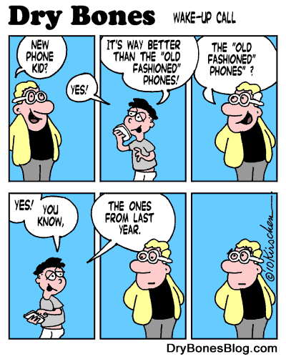
These are among the 75 items on this year's Beloit College Mindset List. The list is assembled each year by two officials at this private school of about 1,400 students in Beloit, Wis. The list is meant to remind teachers that cultural references familiar to them might draw blank stares from college freshmen born mostly after 1990.
Being aware of the generation gap helps professors craft lesson plans that are more meaningful, said Ron Nief, one of the list's creators.

Jessica Peck from Portland, Ore., disagreed with two items on the list - one that says few students know how to write in cursive, and another that suggests this generation seldom if ever uses snail mail.
"Snail mail's kind of fun. When I have time I like writing letters to friends and family," she said. "It's just a bit more personal. And yes, I write in cursive."

Peck did agree with the item pointing out that most teens have never used telephones with cords. "I've used them but only at my grandparents' house."
Definition, Generation Gap:

A difference in values and attitudes between generations, especially between young people and their parents. Many misunderstandings that occur between parents and children are due to a generation gap."

The Pictures
Describe the gaps you see in each picture beginning at the top of L&L.
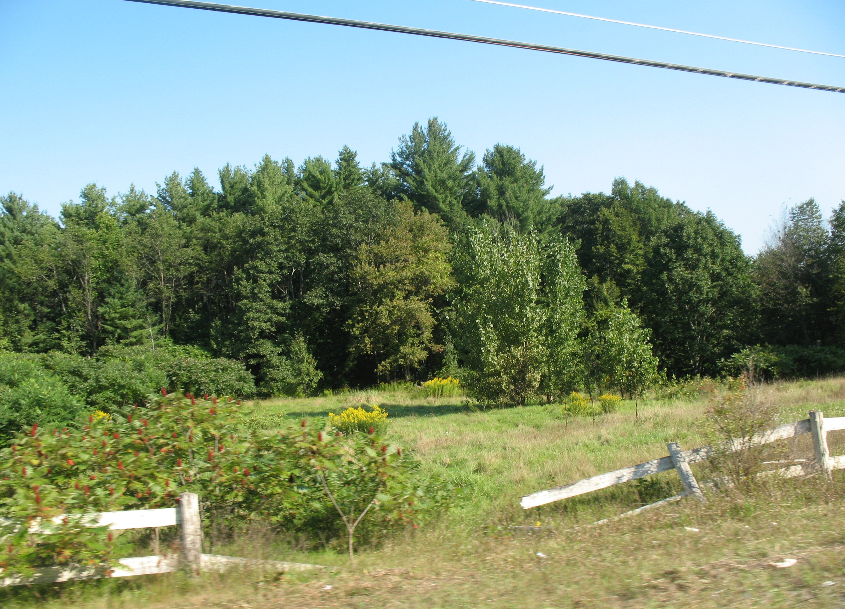


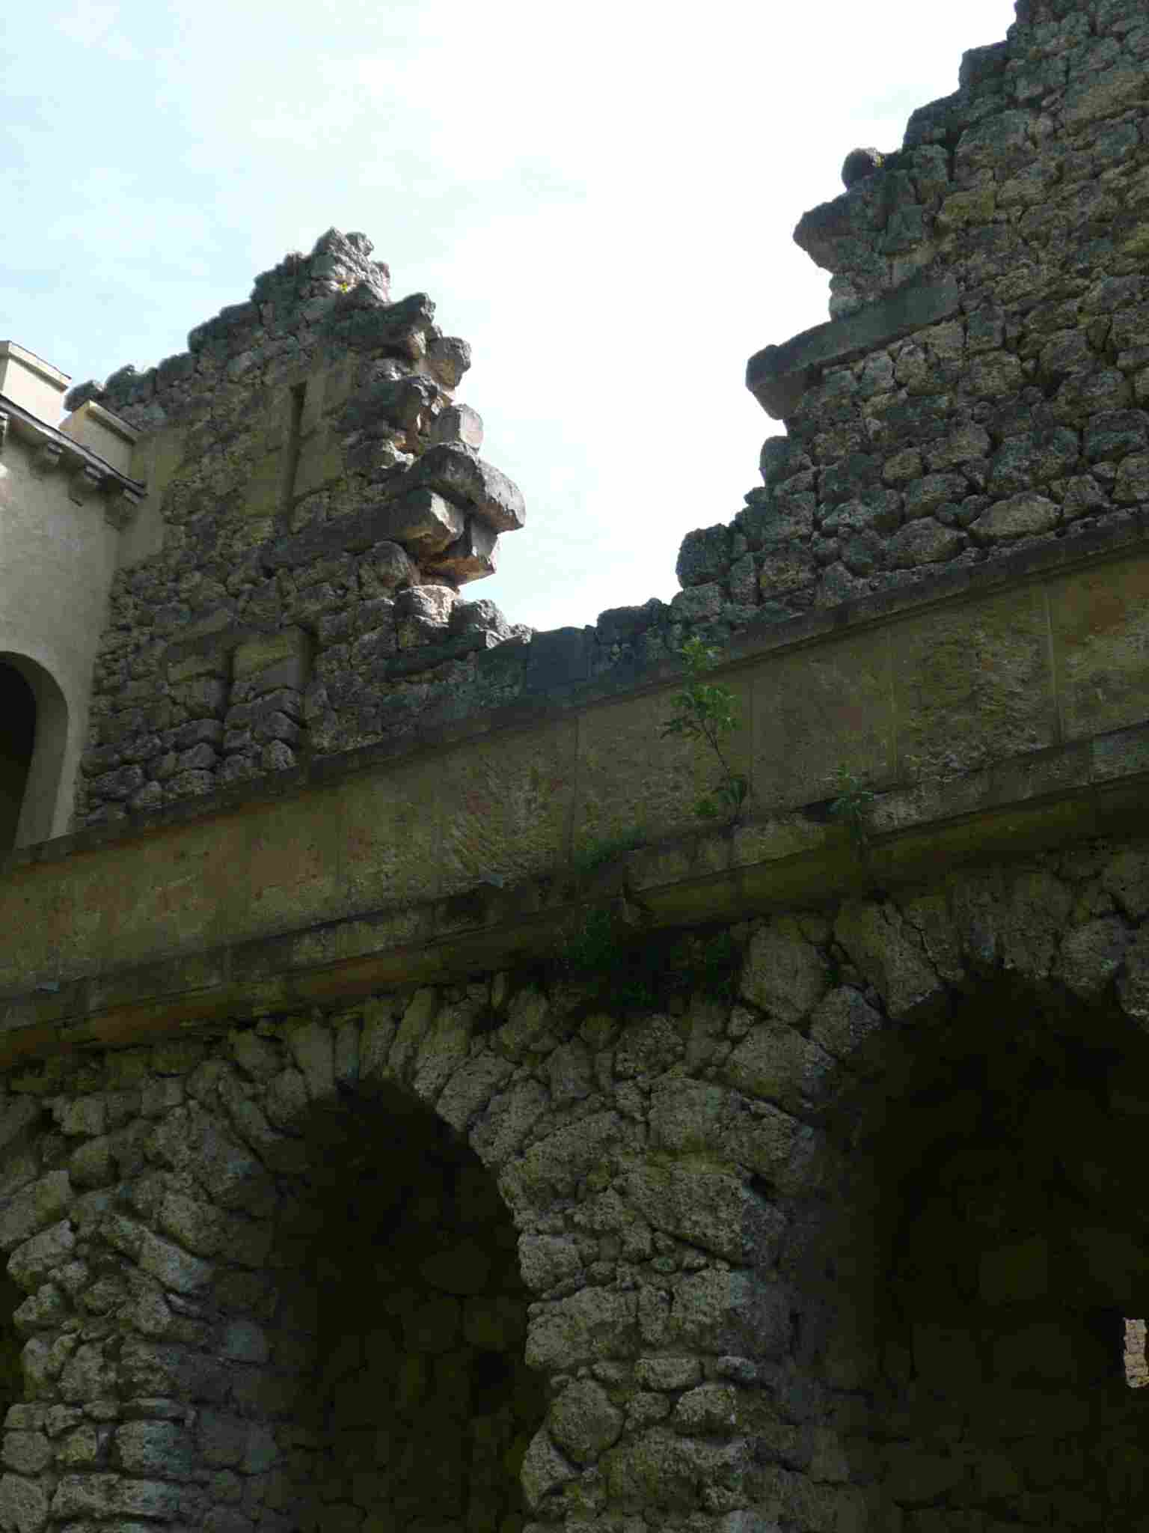
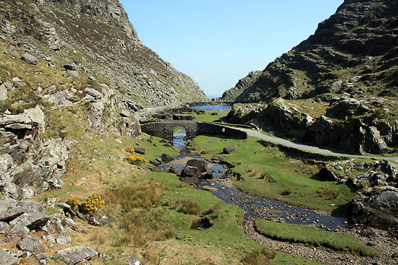

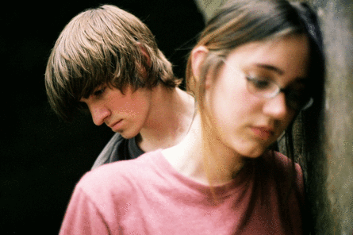

The Links
Generation Gap [1 minute] http://www.youtube.com/watch?v=mAj9eQw9Fvo
Communication Gap with President Bush http://www.youtube.com/watch?v=TN8BabAPzts

Road Gap Jump http://www.youtube.com/watch?v=QhFMfiUHUkg

Kenter Canyon Gap - Mountain Bike Crash http://www.youtube.com/watch?v=k04_VB6vCKM

Gap Mountain Bike Free Ride Competition http://www.youtube.com/watch?v=YOLKE9bMjeA

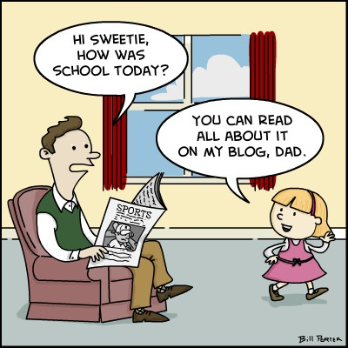
The Laughs

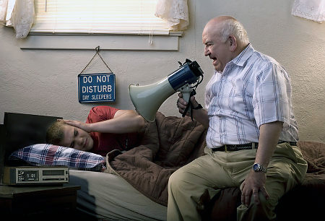
Her class assignment was to interview an "old person" about his life, so my niece asked me, "What was the biggest historical event that happened during your childhood?" "I'd have to say the moonwalk," I replied. She looked disappointed. "That dance was so important to you?"
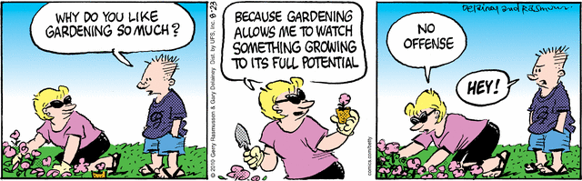

A very self-important college freshman attending a recent football game, decided to explain to a senior citizen sitting next to him why it was impossible for the older generation to understand his generation.
"You grew up in a different world, an almost primitive one," the student said, loud enough for many of those nearby to hear. "The young people of today grew up with television, jet planes, space travel, our space ships have visited Mars. We have nuclear energy, electric and hydrogen cars, computers with light-speed processing and...," pausing to take another drink of beer.
The older man took advantage of the break in the student's rambling speech and said, "You're right, young man. We didn't have those things when we were young... so we invented them. Now, what are YOU and your friends doing for the next generation?" The applause was loud and long.



