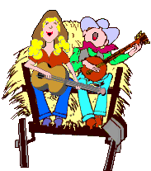
Laugh and Learn

Hayride fun

Autumn Tradition

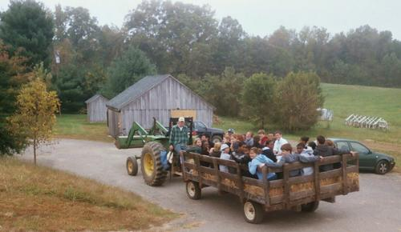
The Learn
Autumn in the Heartland is not complete without pumpkin pie, apple cider, and of course the annual hayride. Hayrides are as common in autumn as sledding in winter.
Hayrides have been a feature of autumn harvest celebrations for hundreds of years. They were popular in rural America at least as far back to the 17th Century, when early English settlers enjoyed their successful farm season with music, dancing and food.
As poets and songwriters have emphasized over the centuries, the wagon full of young men and women each harvest season signaled romantic hayrides through the countryside. Of course, the custom is enjoyable for children and friends of any age.
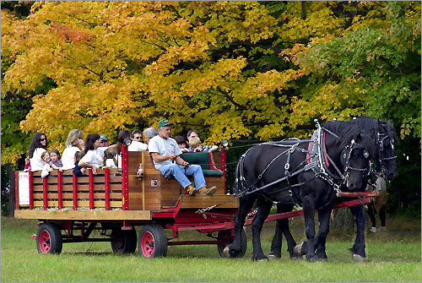
The rules, if there really are any, are very simple, and you should thoroughly enjoy yourself after making some basic preparations.
1. Dress for the ride: If the event calls for special costumes, be sure to check about how to dress with the organizers. For example: An Old West theme would encourage cowboy and cowgirl clothing, hats and boots.
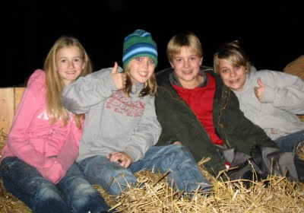
2. Dress warm: Hayrides can be a bit chilly, especially those that are planned for nights. If you start off lightly dressed in the warm sunset, bring jackets for later. Blankets are helpful as the night gets cooler, and are excellent snuggling wraps for those who require close encounters in the hay.
3. Take necessary items: A flashlight can always come in handy, especially if the night is dark and you want to identify the person next to you before things go any further.
4. Bring your voice to scream sometimes and also to sing with your hayride friends. Be prepared to throw hay and have it thrown at you…in your face and down your shirt. Look for the big and little dipper among the stars. Try to scare someone. Hold hands.
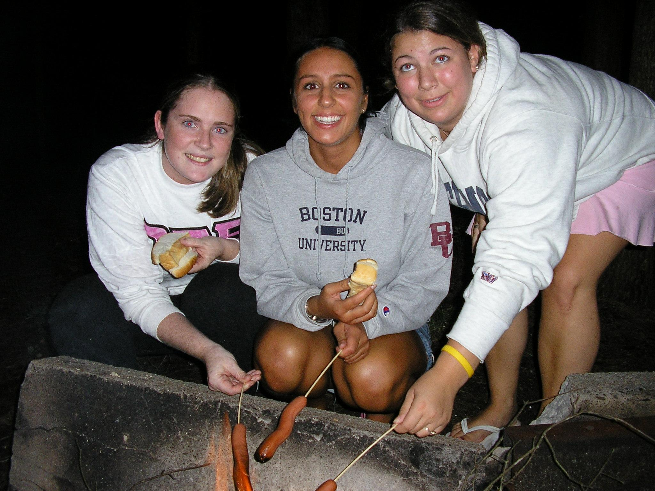
5. Of course, you shouldn't have matches or lighted cigarettes in that easily flammable wagon full of hay and people.
6. The Hayride will conclude with a campfire, roasting hot dogs and making S’mores. Ask what you should bring so there will be food for everyone.
7. Some hayrides are planned to be scary and should be done at night. A “haunted hayride" may be just what is needed this year. Actors can play the parts of ghouls and goblins and jump out of the forests or tall corn to add some screams and adrenaline to the hayride.
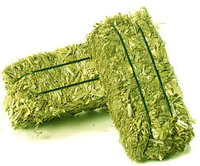
Words to know:
Hay: It is really straw, which is the stem that supports grains such as wheat or rye or oats.
Bale of Hay: A tightly bound bundle of straw. See picture.
Hayride: Also Hay ride. An autumn adventure with friends on a tractor or horse pulled wagon of straw.
Apple cider: Freshly pressed apple juice.
Flashlight: a handheld light powered by batteries
Heartland: The central part of the USA with many family farms
S’mores: A campfire dessert treat. S’more is a contraction of “some more.” When you eat one you’ll want some more, or s’mores. Directions or s’mores are in the links.

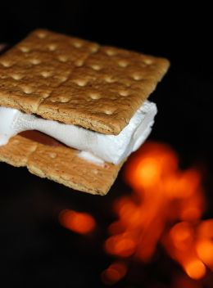
The Links
How to plan a hayride
http://www.youtube.com/watch?v=h0tbz7QEmOQ

Hayride Fun
http://www.youtube.com/watch?v=kVYbCbm5yp0

How to Make S'MORES
http://www.youtube.com/watch?v=4Kk7i_d4kQU
http://www.youtube.com/watch?v=spi6b389jmM

Fall Color tours
http://www.travelandleisure.com/articles/americas-best-fall-color-drives/1

The Laughs
TEACHER : What's the longest word in the English language ?
Pupil : Smiles - because there is a mile between the first and last letters
TEACHER : What is further away, Australia or the Moon ?
Pupil : Australia, I can see the Moon at night .
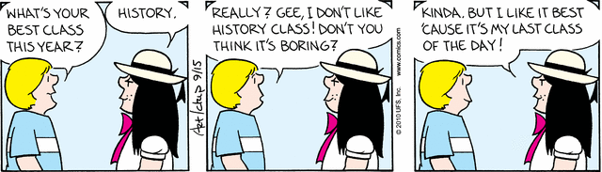

Summer vacation was over and Little Honza returned back to school. Only two days later his teacher phoned his mother to tell her that he was misbehaving. "Wait a minute," mom said. "I had Honza with me for three months and I never called you once when he misbehaved!"
Autumn -- time to drag out your winter clothes and see what kind of summer fun the moths had.
I got tired of looking at all those leaves in my yard, so I got up off the couch and went into action. I closed the curtains.

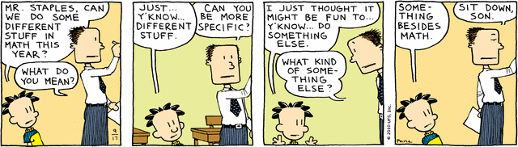

Teacher: Class, we will have only half a day of school this morning. Class: Hooray Teacher: We will have the other half this afternoon
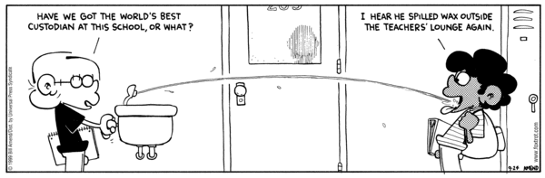
"If there are any idiots in the room, will they please stand up" said the sarcastic teacher.
After a long silence, one freshman rose to his feet.
"Now then mister, why do you consider yourself an idiot?" enquired the teacher with a sneer.
"Well, actually I don't," said the student, "but I hate to see you standing up there all by yourself."

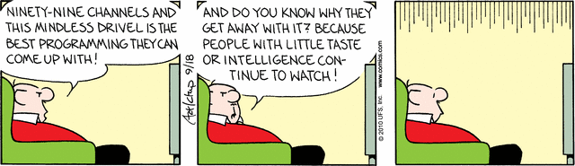

The children were lined up for lunch in the cafeteria of a Catholic elementary school. At the head of the table was a large pile of apples. A nun made a note, and posted on the apple tray: "Take only ONE. God is watching."
Moving further along the lunch line, at the other end of the table was a large pile of chocolate chip cookies. A child had written a note, "Take all you want. God is watching the apples."

The teacher of the earth science class was lecturing on map reading.
After explaining about latitude, longitude, degrees and minutes the teacher asked, "Suppose I asked you to meet me for lunch at 23 degrees, 4 minutes north latitude and 45 degrees, 15 minutes east longitude...?"
After a confused silence, a voice volunteered, "I guess you'd be eating alone."

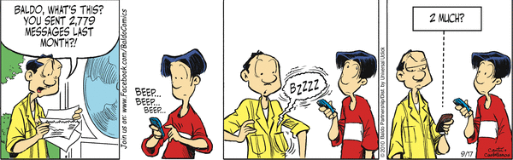

The child comes home from his first day at school. Mother asks, "What did you learn today?"
The kid replies, "Not enough. I have to go back tomorrow."

Teacher: If I give you two rabbits and two rabbits and another two rabbits, how many rabbits have you got?
Veronika: Seven!
Teacher: No, listen carefully again. If I give you two rabbits and two rabbits and another two rabbits, how many rabbits have you got?
Veronika: Seven!
Teacher: Let's try this another way. If I give you two apples and two apples and another two apples, how many apples have you got?
Veronika: Six.
Teacher: Good. Now if I give you two rabbits and two rabbits and another two rabbits, how many rabbits have you got?
Veronika: Seven!
Teacher: How on earth do you work out that three lots of two rabbits is seven?
Veronika: I already have one rabbit at home!

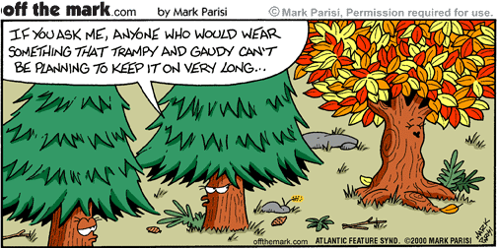

One Last Hay Ride Picture



