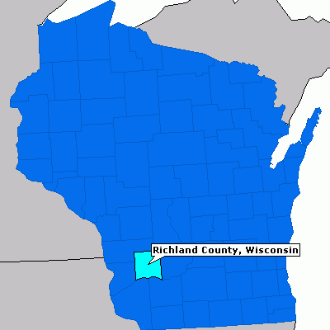
Laugh and Learn

Svetlana Stalin

In Wisconsin

Right: Map showing Richland County, Wisconsin

The Learn
It wasn’t New York that attracted the most early Czech immigrants, but Wisconsin. Wisconsin became a state in 1948, which also the year of the beginning of the mass emigration from the Austrian Empire to the United States. Wisconsin wanted to attract settlers and developed advertising to welcome Czech emigrants.
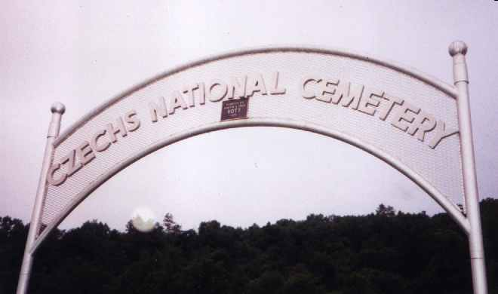
One advertisement pamphlet read. "Come! In Wisconsin all men are free and equal before the law... Religious freedom is absolute and there is not the slightest connection between church and state.
So many Czech immigrants settled in western Wisconsin that Richland Center has the National Czech Cemetery and nearby are Bohemian Valley and the village Mr. Tabor.
More recently this center for Czech Americans has attracted one unusual person.
Svetlana Stalin
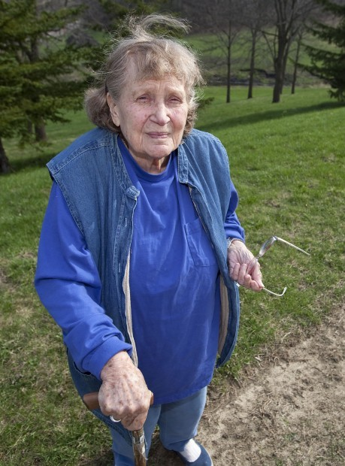
She lives in a one-bedroom apartment in Richland Center, surrounded by photos of her daughter.
Newspaper reporter Doug Moe asked: "Do your neighbors know your background?"
"I don't know," she said with a smile. "Probably they will now."
Lana Peters, 84, is the only daughter of Josef Stalin, the brutal dictator of the Soviet Union who died in 1953. Her defection to the U.S. in 1967 - when she was known as Svetlana Alliluyeva - made headlines around the world. Peters first came to Wisconsin in 1970 and to Richland Center three years ago.
Lana is a small woman. She uses a cane and has some difficulty walking, but her mind is lively. She smiles often. She likes to sew and read, mostly non-fiction. She listens to public radio and doesn't own a TV.
"I am quite well and happy," she said. "Richland Center has a hospital and good social services for seniors. I have an American-born daughter. The only unhappiness of my life is that I would like to live closer to her." The daughter, Olga now goes by the name Chrese Evans and lives in Portland, Ore.
The daughter was the result of Peters' 1970 marriage to William Wesley Peters, an apprentice of the famous architect Frank Lloyd Wright. After her defection to the U.S., she said, Olgivanna Lloyd Wright invited her to visit. I could not refuse her because she was an old lady and she wrote me very sweet letters."
Svetlana moved to Wisconsin and the result was a fast romance - just a few weeks - ending in a brief marriage to Wes Peters, and a daughter.
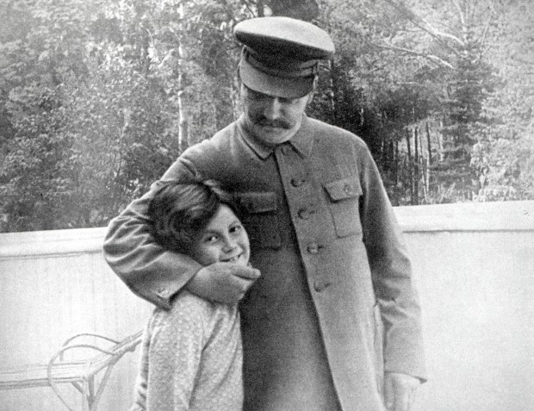
Svetlana was asked if she thinks often of her father. "No," she said. "He broke my life. I want to explain to you. He broke my life twice."
She said she had fallen in love with an older man, a writer and filmmaker named Aleksei Kapler. Her father did not approve.
"I was 17," she said. "He put to jail, and then to labor camp, the man who I loved. I saw for the first time that my father could do that."
Kapler had introduced her to the arts - giving her books and taking her to galleries.
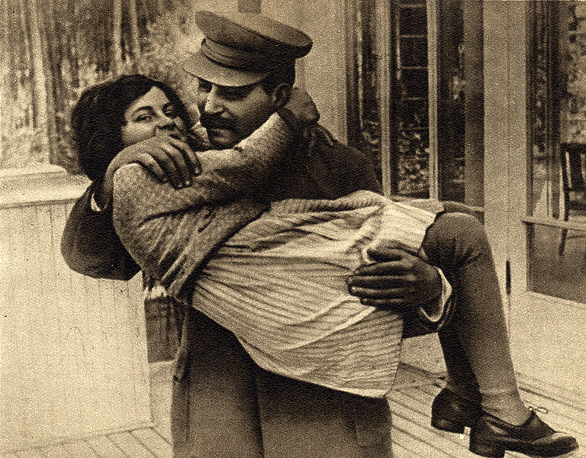
Peters said the second time her father "broke" her life came when she applied at a university to study the arts. Josef Stalin scoffed.
"Bohemians," Peters recalled him saying. "You want to be with Bohemians?" He insisted she study history and become "an educated Marxist."
Peters was asked: "Do you think your father loved you?"
"Oh, yes," she said. "I looked like his mother. I had this red hair, which I still have. It's not colored. It's my own hair. I have freckles all over, like her."
She continued: "He was a very simple man. Very rude. Very cruel. There was nothing in him that was complicated. He was very simple with us. He loved me and he wanted me to be with him and become an educated Marxist."
Now the daughter of the man who despised Bohemians lives in the Czech city called Richland Center. "I have many friends here." Also Lana and her daughter speak most nights on the phone.
Peters has reconciled herself to one reality. "Wherever I go," she said, "here, or Switzerland, or wherever, I will always be a political prisoner of my father's name."

1946 school class in Richland County, WI. Look at the Czech names
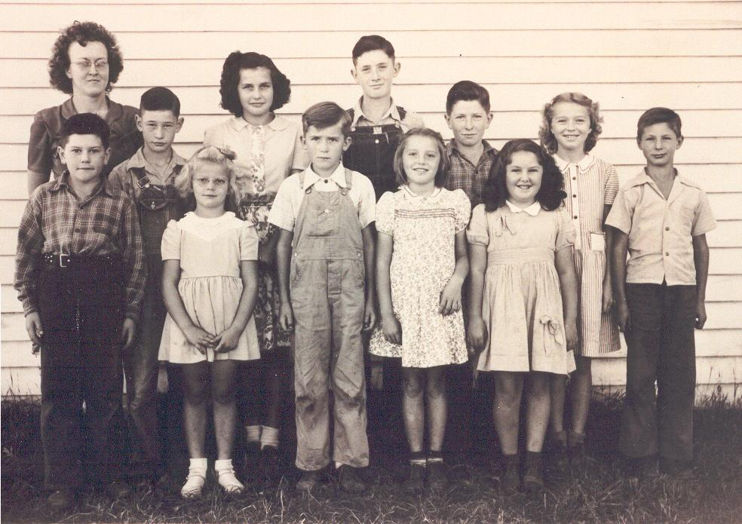
Back row, left to right- Mrs. Vanourek, Bernard Shields, Wilma Janecek, Clarence Shields, Francis Jelinek, Ellen Bruce, Larry Liska.
Front Row, left to right- Ronald Jelinek, Janet Dvorak, Donald Janecek, Arlene Bruce, Jeannette Dvorak.

The Links
A palindrome reads the same backwards as forward. This video reads the exact opposite backwards as forward.
This is only a 1 minute, 44 second video and it is brilliant!
This is a video that was submitted in a contest by a 20-year old.
The contest was titled "u @ 50."
When they showed it, everyone in the room was moved with awe and broke into applause. So simple and yet so brilliant. Watch and enjoy,
http://www.youtube.com/watch_popup?v=42E2fAWM6rA

American made, Czech pride
http://www.youtube.com/watch?v=c3ZrbDi8aLQ

City made of toothpicks [nothing Czech here]
http://www.funmunch.com/funpages/art/toothpicks_art/

Men can fix anything
http://www.funnyjunk.com/funny_pictures/306554/Men+Can+Fix+Anything/
The Laughs
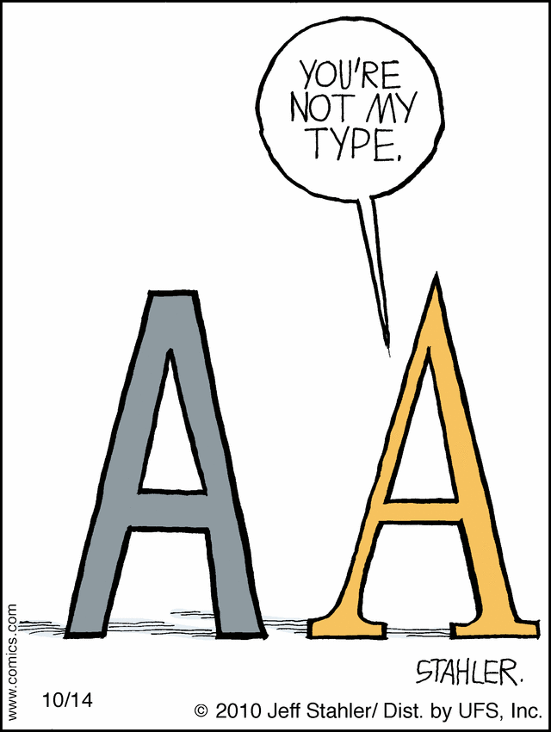


Two friends meet in the street. The first asks "How are you?" and the second immediately begins telling the other his problems. The first becomes annoyed and says: "You didn't ask me how I am.'"

The second looks a bit surprised and says, "Well, how are you?" "Don't ask," replies the first.

A girl comes home with her report card and shows it to her father. "All good grades, except you failed English," he says angrily, "What's the matter with you. Don't you know that half the world can speak English?"
Yes," she said, "but don't you think that's enough."

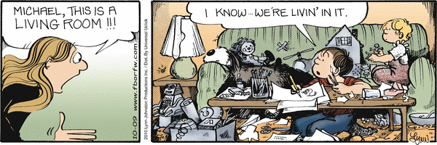

Two Americans are lost while hiking through the hills. One says to the other, "Shoot into the air, maybe somebody will hear us." The other shoots into the air, but nobody comes. Several hours later, the first says, "Try shooting again, maybe somebody will hear us." The other shoots into the air, but nobody comes. Several hours later, the first says, "Try shooting into the air one more time." "I can't," says the second, "I'm out of arrows."
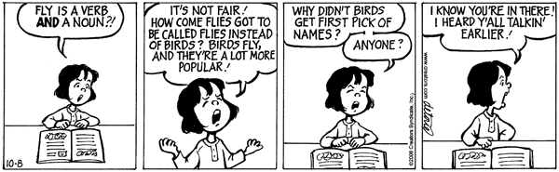

A cowboy rode into town and stopped at the saloon for a drink. Unfortunately, the locals always had a habit of meanness to newcomers. When he finished, he found his horse had been stolen.
He comes back into the bar, spins his gun and throws it into the air, catches it above his head, and without looking fires a shot into the ceiling. "Who stole my horse?" he yelled with surprising forcefulness. No one answered.
"I'm going to have another drink and if my horse isn’t back when I'm finished, I'm going to do what I did back in Texas and I don't want to have to do what I did back in Texas!"
Some of the local people shifted restlessly. He had another beer, walked outside, and his horse was back! He saddled up and started to ride out of town.
One man stepped out of the bar and asked, "Say partner, what happened in Texas?"
The cowboy turned back and said, "I had to walk home!"
If a cowboy rides into town on Friday and three days later leaves on Friday, how does he do it? The horses name is Friday!

The best way to have a quiche for dinner is to make it up and put it in the oven to bake at 325 degrees. Meanwhile, get out a large T-bone, grill it, and when it's done, eat it. As for the quiche, continue to let it bake, but otherwise ignore it.



