Laugh and Learn
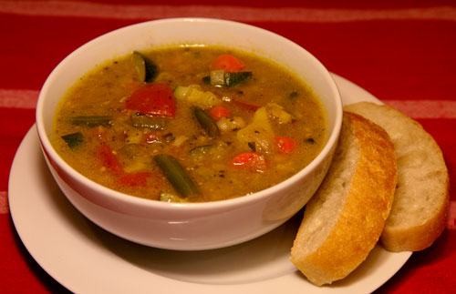
It’s the Season
For All
the bowls
In the u.s.a.

The Learn
Hi friends and neighbors, students and workers, who are interested in English and maybe also curious about the USA. In the USA it is now Bowl season. Bowl Season begins the day after Christmas [approximately] and continues to February 6 this year.
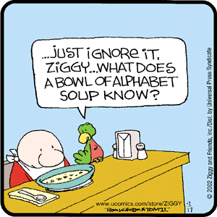
When you think of the word bowl, what comes to your mind? In the USA winter is an especially good time for a bowl of hot soup. In the Czech Republic we eat bowls of soup year around. In the USA we enjoy vegetable soup, chicken soup, chili soup, and even a soup for English students. It is called alphabet soup. Really…No joke!

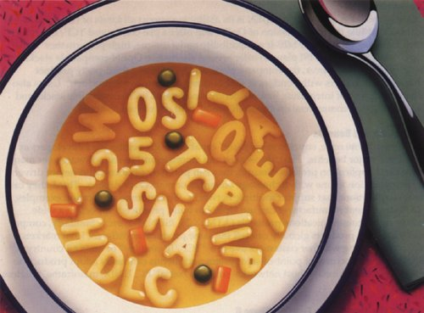

Bowl can also refer to bowling, which is a great winter sport…if you like winter sports that don’t require boots and gloves. The PBA [Professional Bowling Association] Tournament of Champions will be held January 15-22 in Las Vegas. The tournament will feature a $1 Million prize fund, with $250,000 going to first place. The event is open to any PBA member who has EVER won a PBA event, National or Regional, it should be one of the most anticipated tournaments of all time. What is your best bowling score? How often do you bowl?
From this sport we have a useful and common idiom: To bowl over, which means “to overwhelm with surprise, wonder, or bewilderment.” “When I learned that I had won the lottery I was bowled over.” [a good surprise.] “When I saw the auto repair bill I was bowled over.” [oops…not a good surprise feeling].
But during the six weeks from Christmas to early February Bowl means American football. The climax of the football season is a large number of bowl games. First the universities have about 70 bowl games, with a dozen or more of these during the New Year’s holiday. The best university football teams with strong winning records are invited to play in bowl games. Why are these games called bowl games? Look at this stadium for a hint.

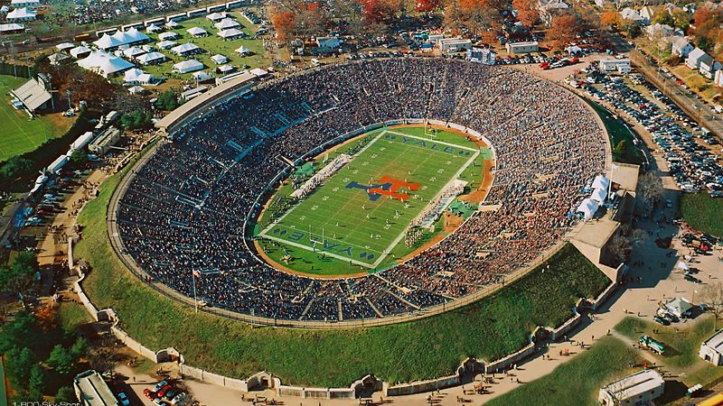
American football stadiums are shaped like giant bowls.
What country is also shaped like a bowl? Think close to home. With a little imagination you could call the Czech Republic a bowl since it is surrounded by a circle of mountains.
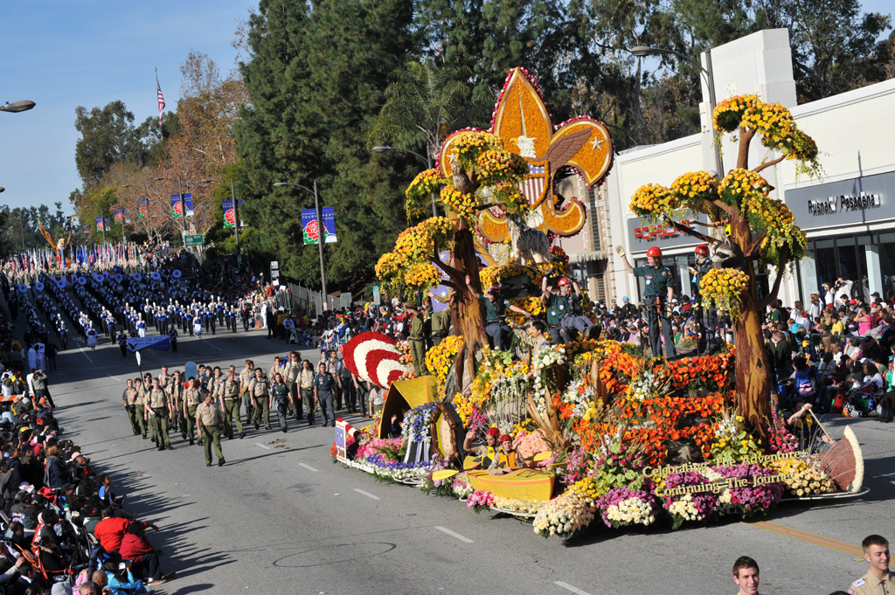
The most famous Bowl university game is the Rose Bowl on January 1. It was the first Bowl game nearly 100 years ago, and is still the best known of all bowl events. The Rose bowl is an important football game, and it is preceded by America’s most famous parade, The Rose Parade. In the Rose parade all the decorated floats [decorated vehicles] are 100% covered with flowers, nothing but flowers, millions of flowers.
The biggest Bowl of all will happen February 6. It is called the Super Bowl. The Super Bowl is the championship game of the National Football League. The day on which the Super Bowl is played is now considered a de facto [traditional but not officially declared] American national holiday, called "Super Bowl Sunday". It is the second-largest day for U.S. food consumption, after Thanksgiving Day. In most years, the Super Bowl is the most-watched American television broadcast.
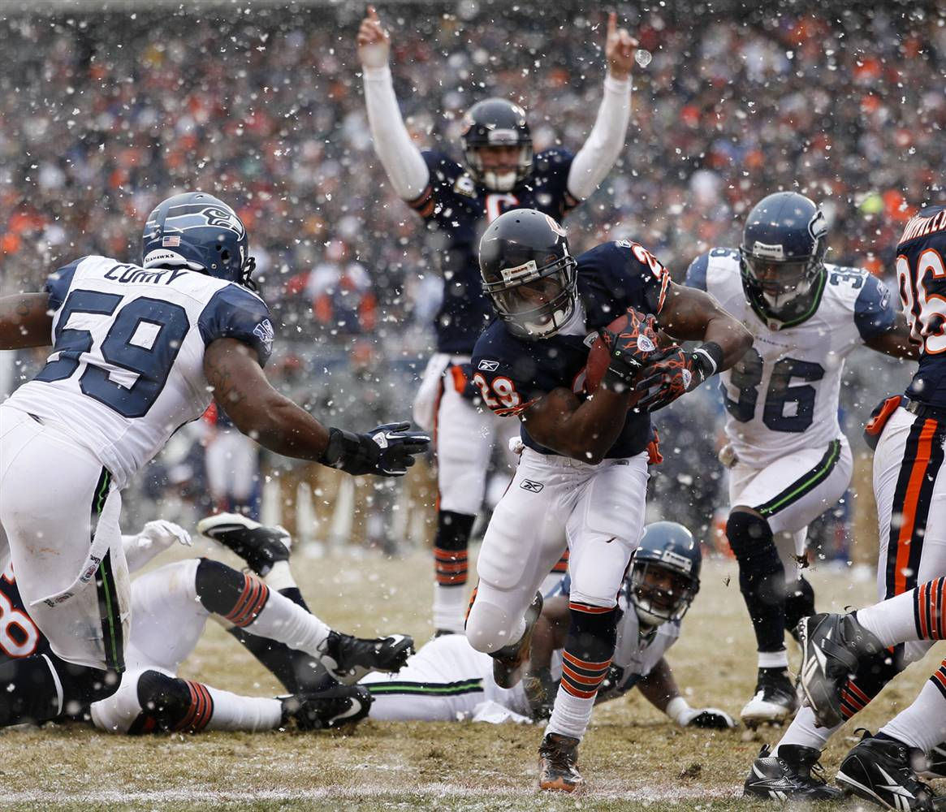
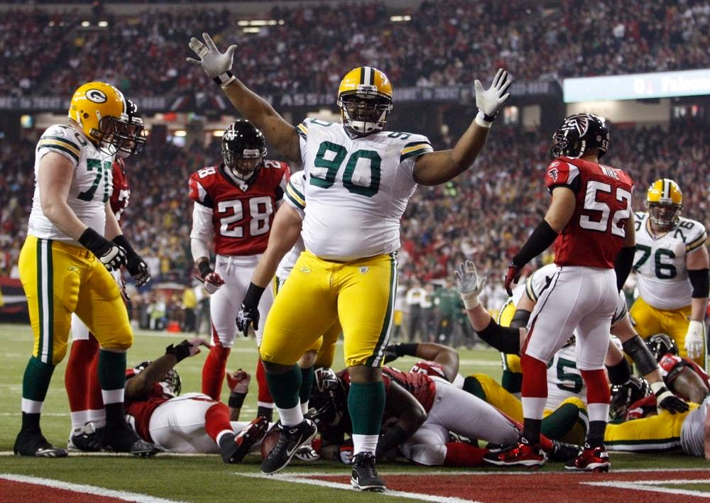
The Links

Chicago Bears-Super Bowl Shuffle – the most famous football song ever, by the champion 1985 Chicago Bears http://www.youtube.com/watch?v=VFnbYW8MCXc

The Best of the Super Bowl Commercials 2010 http://www.youtube.com/watch?v=tao76O4F4XI

Super Bowl XLI Highlights --- only for those who want to see USA football http://www.youtube.com/watch?v=8LpCKxdGH_U

A Brief Overview of the 2010 Rose Parade http://www.youtube.com/watch?v=d27_SfdqH9o

The Laughs
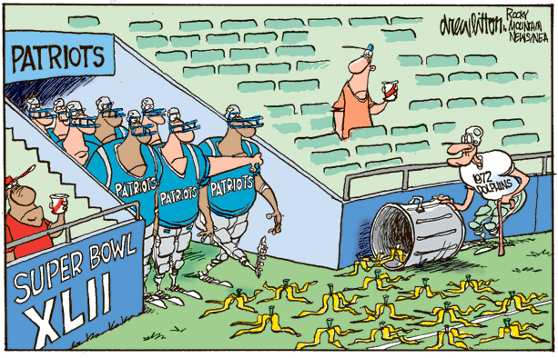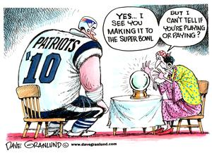
Jim Lewis was thrilled to get a ticket for the Super Bowl. The big day came and he took his seat in the stand. After the pre-game show he noticed the seat in front of him was still vacent. Even after the kick-off nobody was sitting there, so he asked the guy next to the empty seat why nobody was sitting there. The guy replied it would have been my wife's seat but she just died."
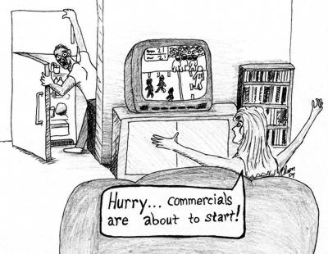
"Well," said Jim man, "why didn't you just bring a friend or relative?"
The guy replied, "Oh, they're all at the funeral."
Right: The Super Bowl commercials are the most expensive and best prepared ads of the whole year. Some people watch the game to see and judge the commercials.
Q: How is the bad economy affecting the Super Bowl?
A: Instead of a coin toss they are now going to play rock, paper, scissors!
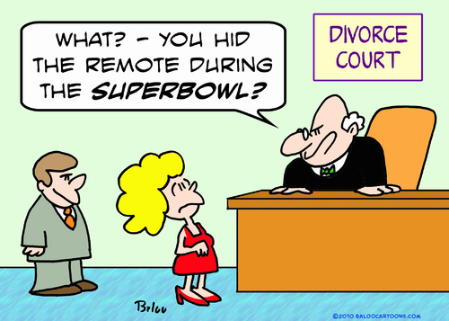
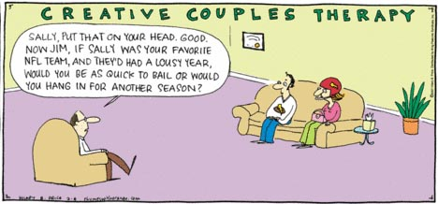
New England Patriots football team had just finished their daily practice session when a large turkey came strutting onto the field. While the players gazed in amazement, the turkey walked up to the head coach and demanded to be given a chance to play at tight end.
Everyone stared in silence as the turkey caught pass after pass and ran right through the defensive line. When the turkey returned to the sidelines, the coach shouted, 'You're superb. Sign up for the season, and I'll see to it that you get a huge bonus.'
'Forget the bonus,' replied the turkey, 'What I want to know is, does your season go past Thanksgiving Day?'
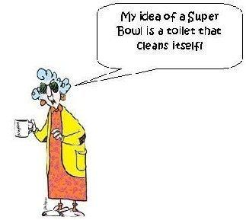
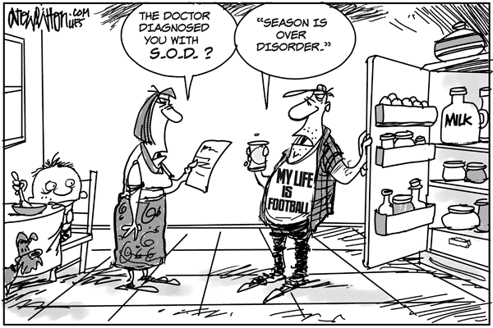

A football coach walked into the changing room before a game. He looked over to his new signing and said, 'I'm not supposed to let you play since you failed arithmetic, but we need you to be in the team. So, what I have to do is ask you a math question, and if you get it right then you will be allowed to play.'
The player agreed, so coach looked into his eyes intently and asked, 'Okay, now concentrate hard and tell me the answer to this. What is two plus two?'
The player thought for a moment and then answered, '4?'
'Did you say 4?' the coach exclaimed, excited that he had got it correct.
Suddenly all the other players on the team began shouting..., 'Come on coach, give him another chance!'
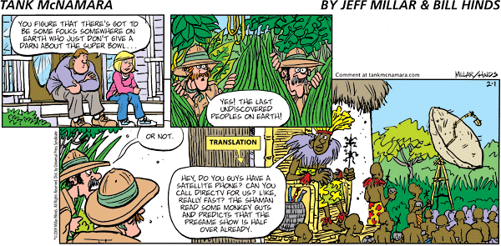
Miss Marie Collins, a first-grade teacher, explains to her class that she is an Pittsburg Steelers fan. She asks her pupils to raise their hands if they are Steelers fans too. Not really knowing what a Steelers fan was, but wanting to be liked by their teacher, their hands fly into the air.
There is, however, one exception. Paula has not gone along with the crowd. The teacher asks her why she has decided to be different.
'Because I'm not a Steelers fan,' she answers.
'Then," asks Miss Collins, 'what are you?'
'I'm a Baltimore Ravens fan,' boasts Paula proudly.
The teacher asks Paula why she is a Ravens fan.
'Well, my Dad and Mum are Ravens fans, so I'm a Ravens fan too, Paula responds.
'That's no reason,' Miss Collins retorts. 'What if your mum was a moron, and your dad was an idiot. What would you be then?'
Paula smiles and says, 'Then I'd be a Steelers fan.'


